FPA INGESTION SCRUM

TEST CASES

Jira link : [https://tesco.atlassian.net/projects/FPA?selectedItem=com.atlassian.plugins.atlassian-connect-plugin:com.kanoah.test-manager__main-project-page#!/v2/testCases?projectId=11014](https://tesco.atlassian.net/projects/FPA?selectedItem=com.atlassian.plugins.atlassian-connect-plugin:com.kanoah.test-manager__main-project-page%23!/v2/testCases?projectId=11014)

Fusion_GL_Balances

Test Case 1 - Validate table delta_gold.fusion_gl_balances and its metadata is matching with Miro/Interface Contract

QUERY : DESCRIBE delta_gold.fusion_gl_balances

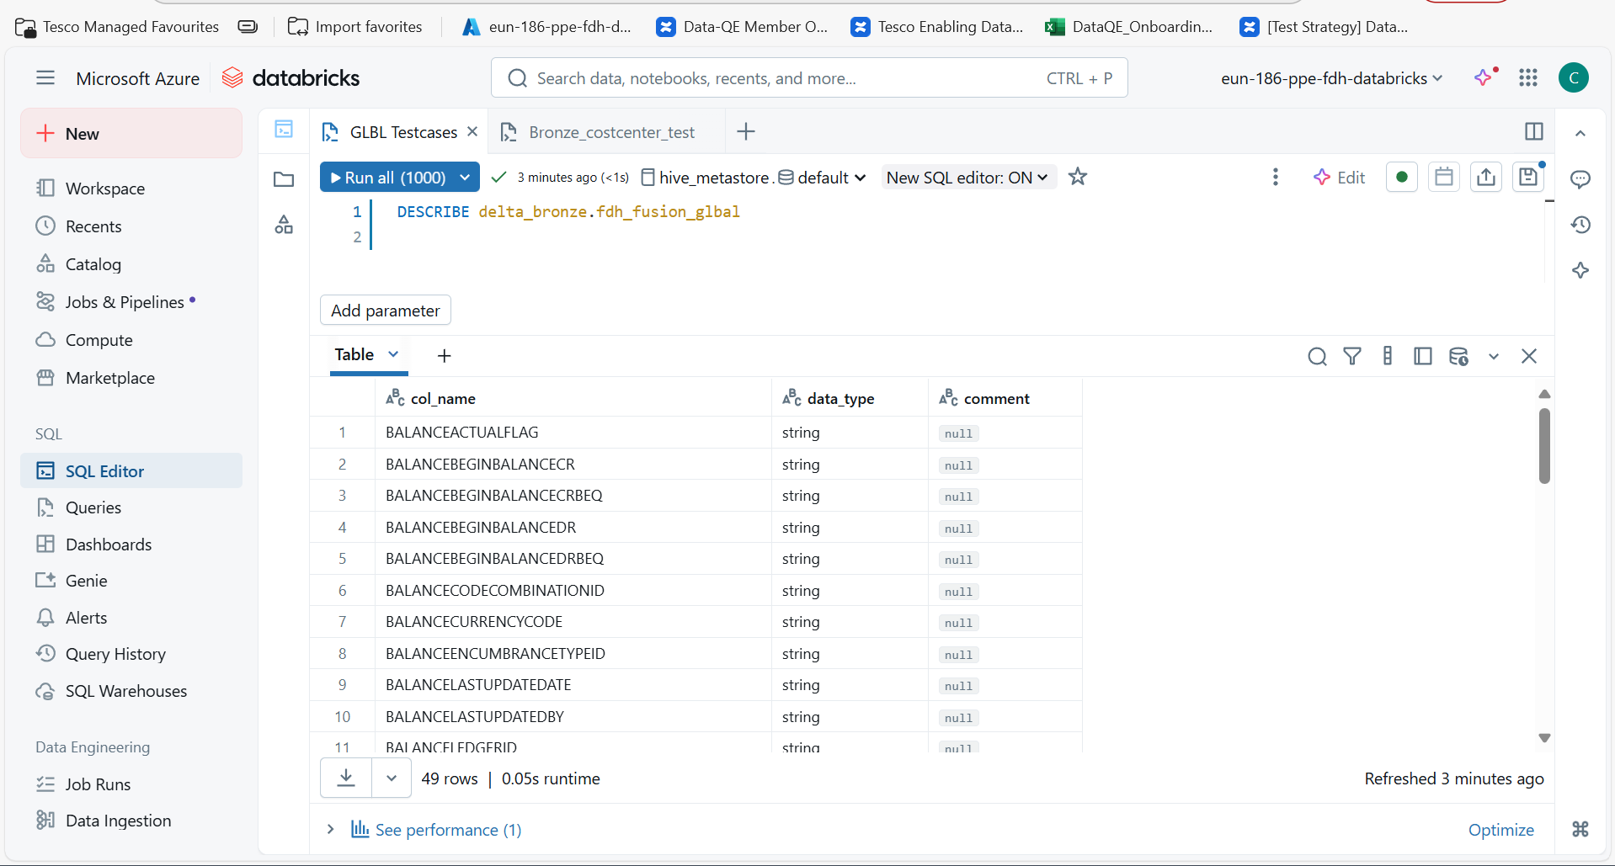

Here I have checked the Metadata ( Column names and data type ) with Miro and Contract too.

TEST CASE 3 : 3-Verify on running the job pl_gold_load manually, if the job is successful Then the data should be moved from silver to gold.

Triggered pl_gold_load pipeline for YPN 202507 and it is successfull

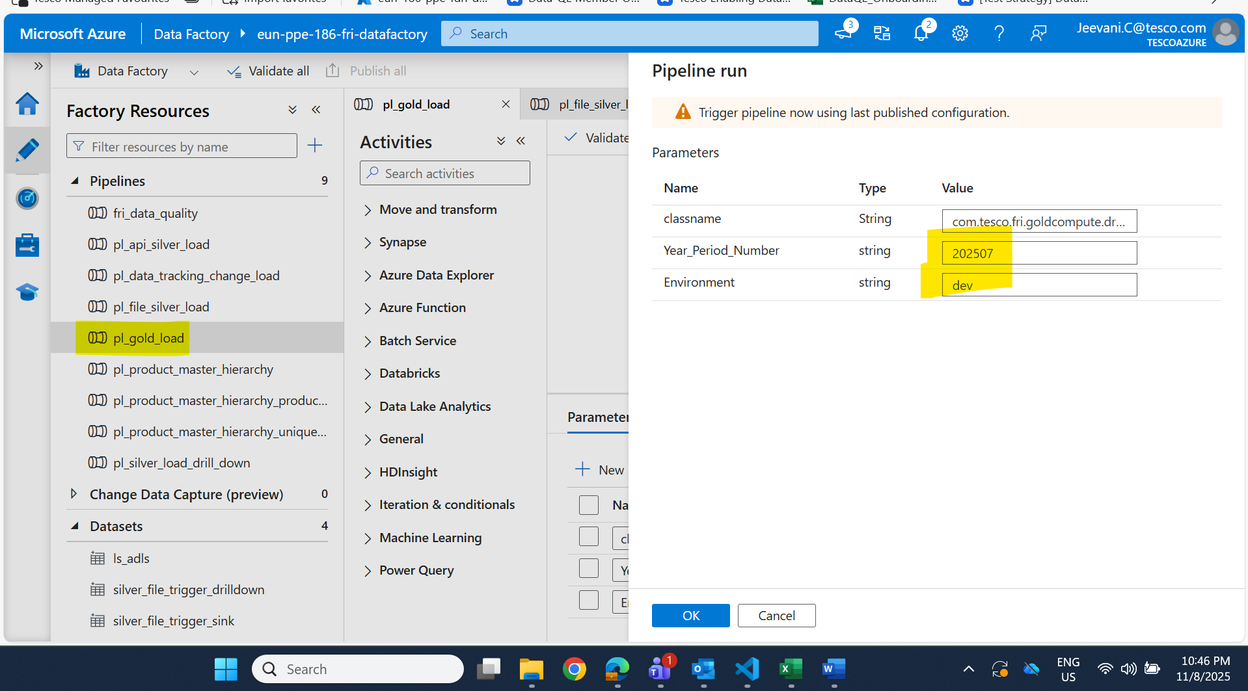

Output:

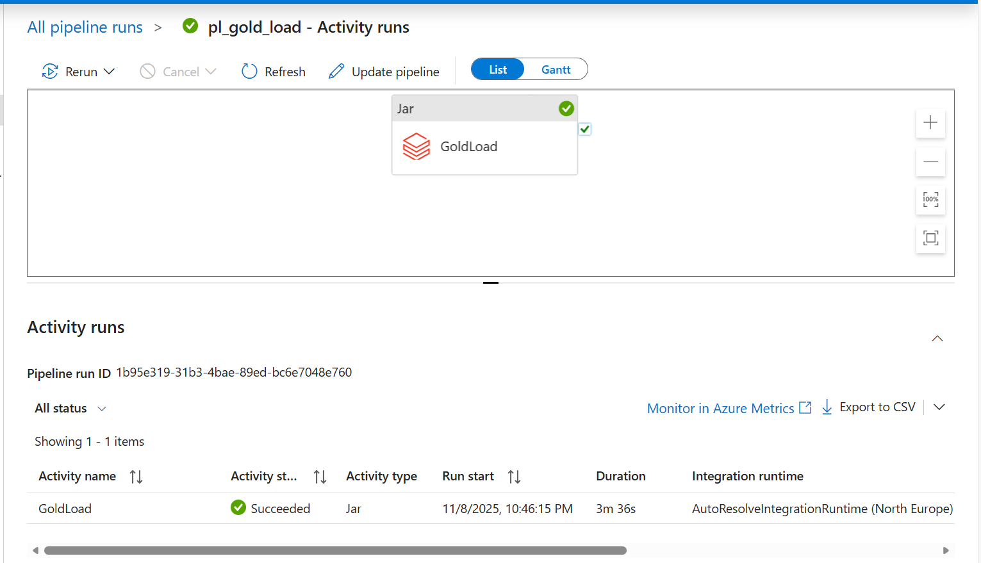

**Test Case 9:** 9-Verify the row count matches between silver and gold layer based on fusion_code, fusion_cost_centre unique combinations

Ensure that the row count for unique combinations of fusion_code (account) and fusion_cost_centre in silver matches the row count for gl_account and gl_cost_centre_code in gold.

Query :

**SELECT COUNT(*) AS silver_count**

**FROM (**

**SELECT fdmee_fusion_string AS fusion_code,**

**source_cost_centre AS fusion_cost_centre**

**FROM delta_silver.fact_fdmee_transformed_data**

**GROUP BY fdmee_fusion_string, source_cost_centre**

**) silver**

**UNION ALL**

**SELECT COUNT(*) AS gold_count**

**FROM (**

**SELECT gl_account,**

**gl_cost_centre_code**

**FROM delta_gold.fusion_gl_balances**

**GROUP BY gl_account, gl_cost_centre_code**

**) gold;**

Output:

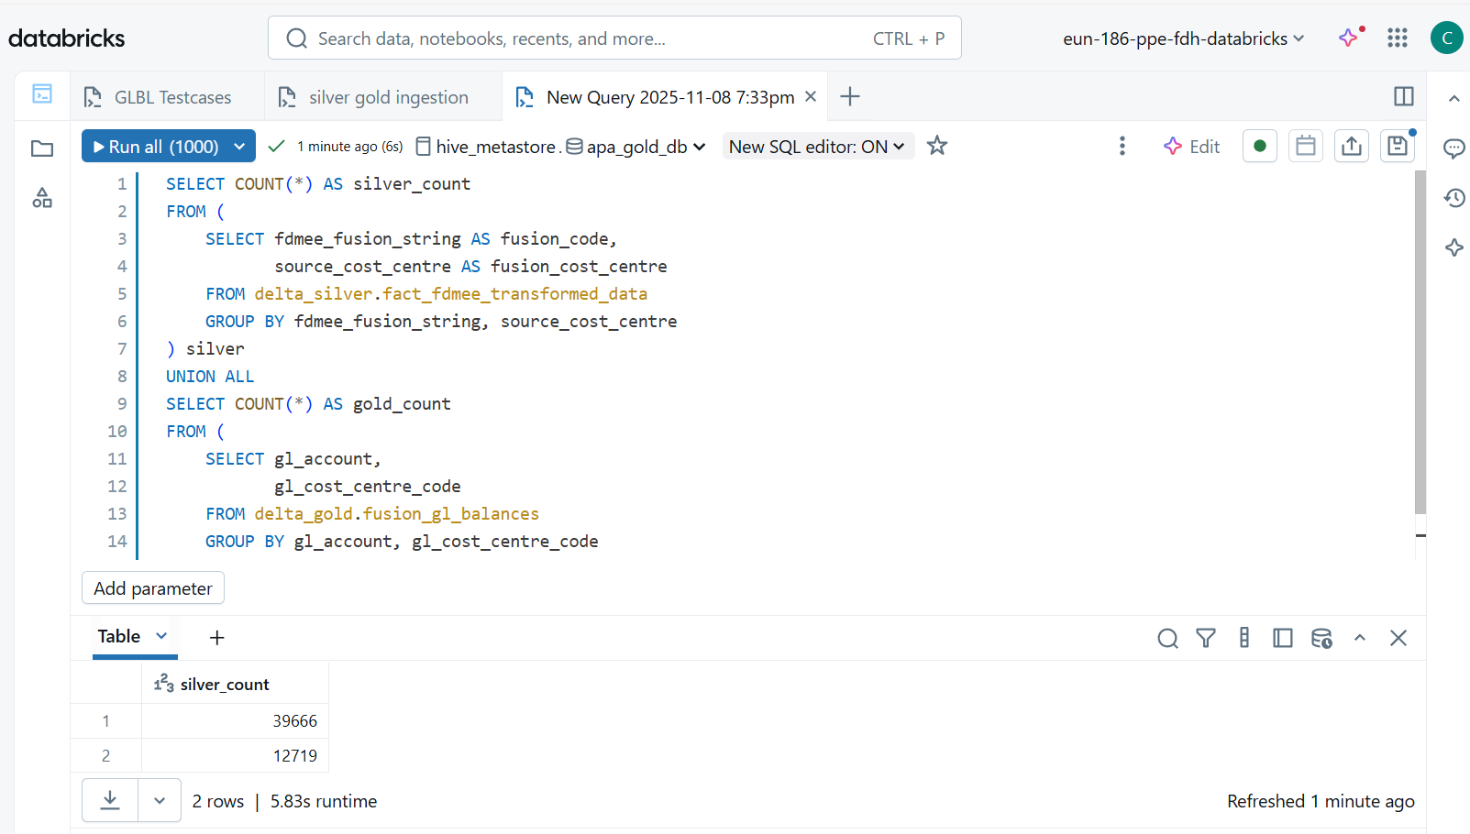

TEST CASE 10 : 10-Ensure YEAR_PERIOD_NUMBER is a 6-digit string (e.g., 202412).

QUERY : SELECT * FROM delta_gold.fusion_gl_balances

WHERE year_period_number IS NULL OR LENGTH(year_period_number) != 6

OR year_period_number NOT RLIKE '^[0-9]{6}$';

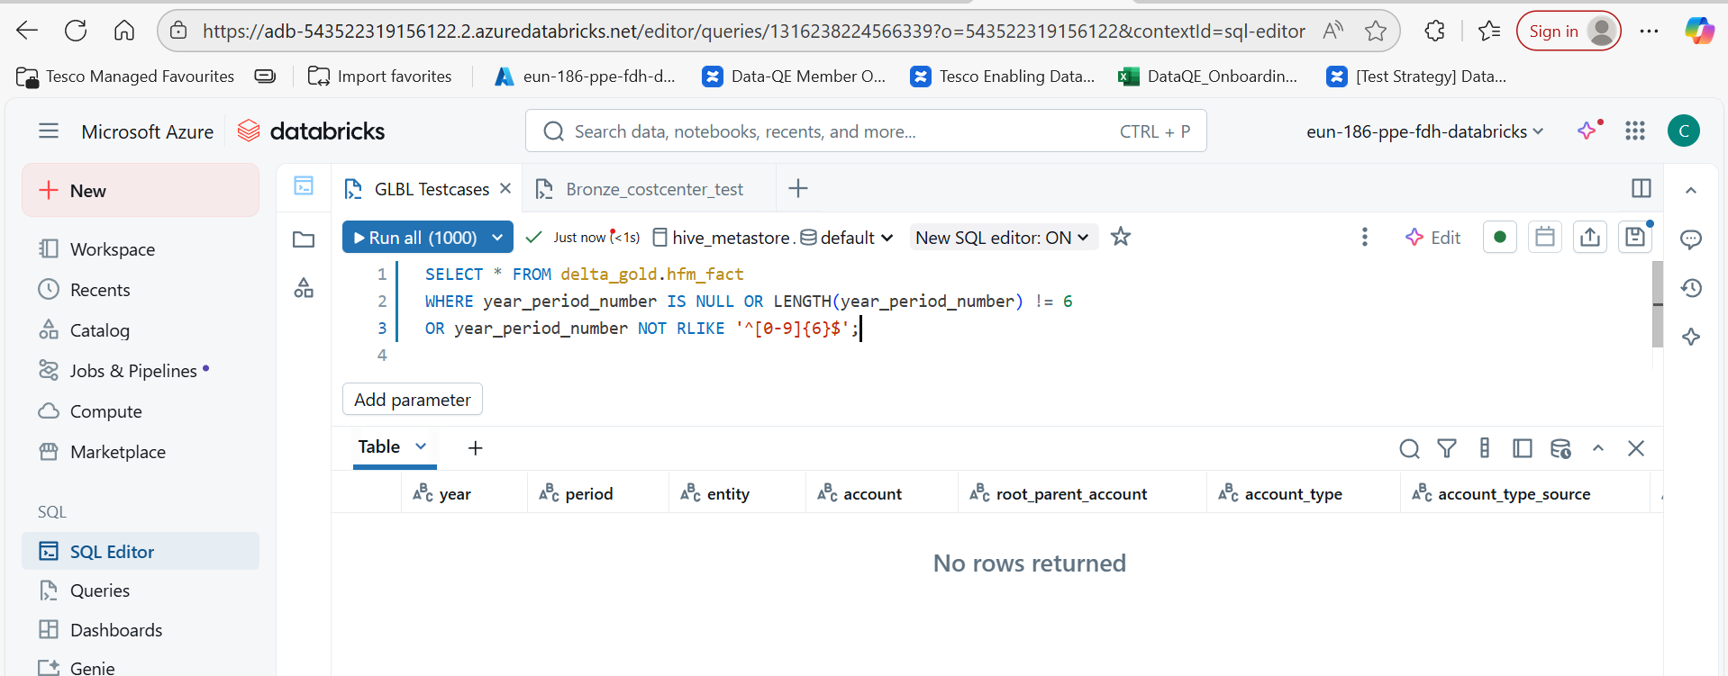

I went to miro and searched for the column year_period_number, I got that hfm_fact gold table has that column, so I have used that table to check the data structure of year_period_number

TEST CASE 13 - 13-Verify if the partition column is year_period_number

QUERY : SHOW PARTITIONS delta_gold.fusion_gl_balances

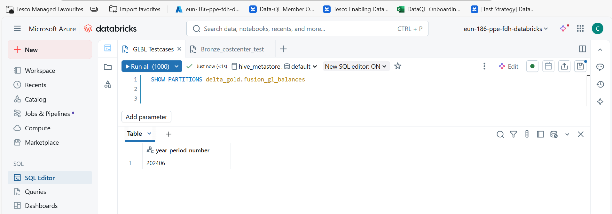  
  
In this table delta_gold.fusion_gl_balances I have checked the partition column used , it shown year_period_number

TEST CASE 15 - Verify the column hfm_entity contains only 3 values 'UKCORE_CF','SB1109','SB1151' and not null

QUERY : SELECT DISTINCT hfm_entity FROM  delta_gold.fusion_gl_balances

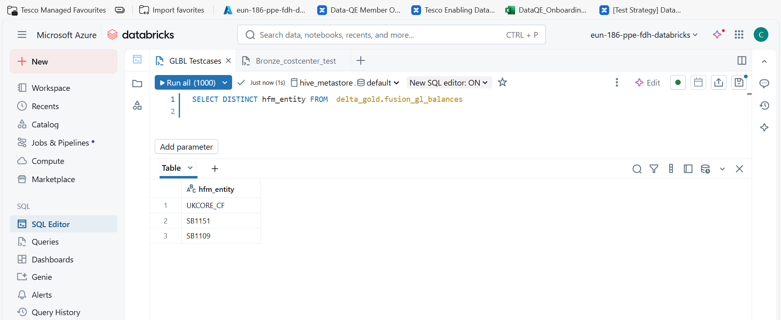

The above query returns only 3 unique set of entity and null is not there so, test case is passed.

TEST CASE 17 : 17-Verify the column gl_period contains only numeric and only 2 digit and not null

QUERY : SELECT * FROM delta_gold.fusion_gl_balances

WHERE gl_period IS NULL or gl_period NOT RLIKE '^[0-9]{2}$'

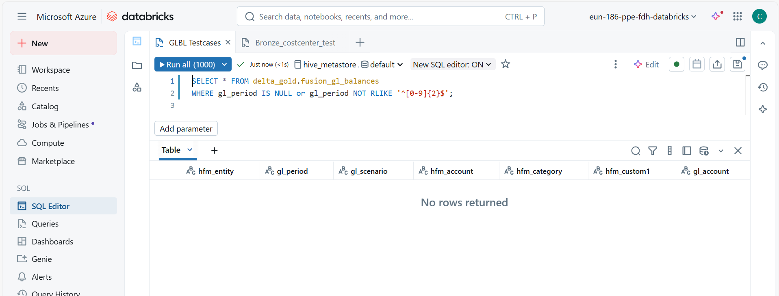

Null rows returns show that all data followed the requested data structure in test case

TEST CASE 19 : 19-Verify the column gl_scenario contains alphanumeric and length is only 7 and not null

QUERY : SELECT * FROM delta_gold.fusion_gl_balances

WHERE gl_scenario IS NULL or gl_scenario NOT RLIKE '^[A-Za-z0-9]{7}$';

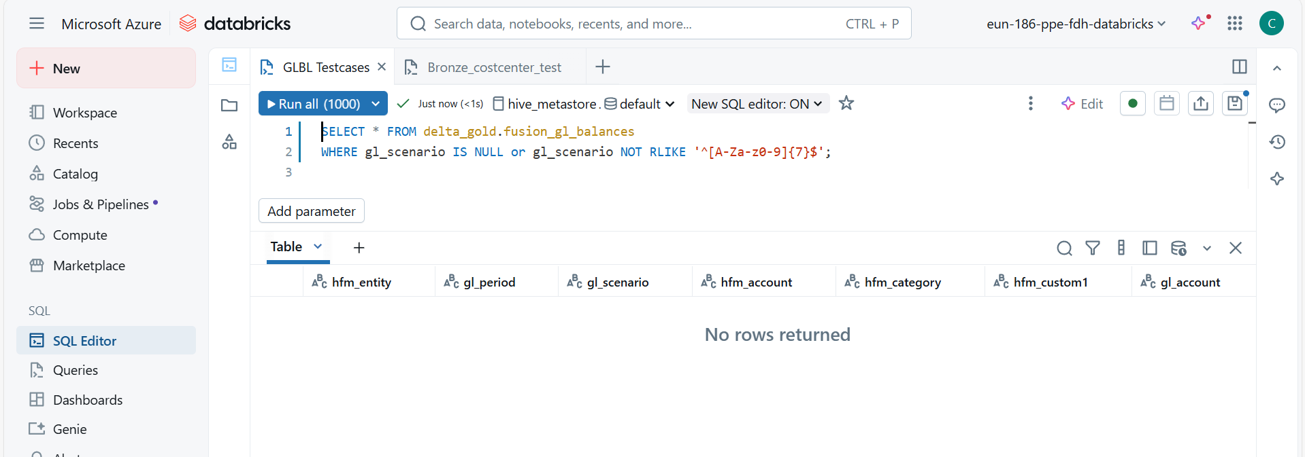

Null rows returns show that all data followed the requested data structure in test case

TEST CASE 22 : 22-Verify the hfm_category is alphanumeric and not null

QUERY : SELECT * FROM delta_gold.fusion_gl_balances

WHERE hfm_category IS NULL or hfm_category NOT RLIKE '^[A-Za-z0-9]+$';

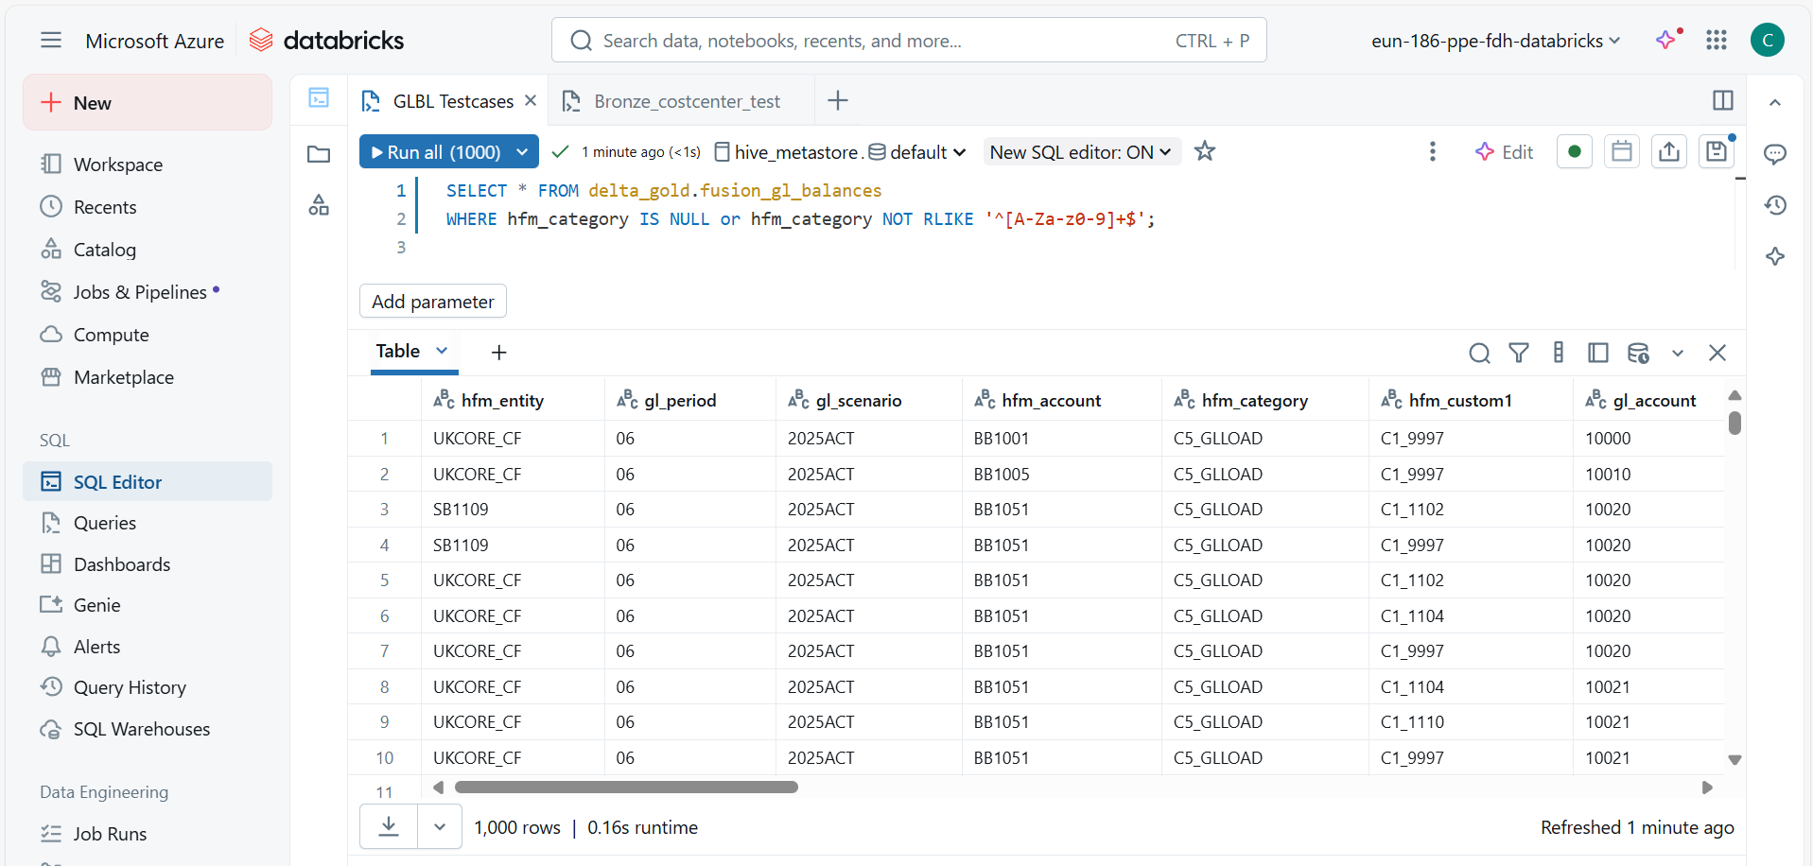

The hfm_catgeory contains ‘_’ (underscore), that why rows are returned, but according to test case it should not be there, underscore, space, @, hyphen (-) etc. should not be consider as alpha numeric

TEST CASE 24 and 26 : 26-Verify the column gl_cost_centre_code is alphanumeric and contains null

QUERY : SELECT * FROM delta_gold.fusion_gl_balances

WHERE gl_cost_centre_code IS NULL or gl_cost_centre_code NOT RLIKE '^[A-Za-z0-9]+$';

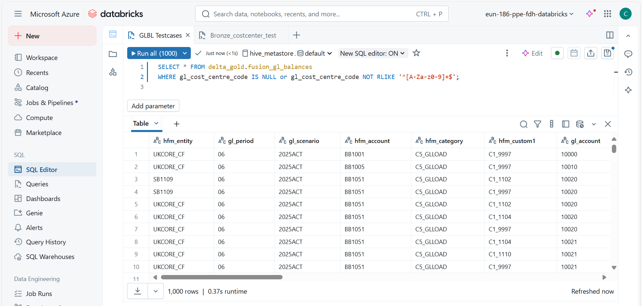

The gl_cost_centre_code contains ‘_’ (underscore), that why rows are returned, but according to test case it should not be there, underscore, space, @, hyphen (-) etc. should not be consider as alpha numeric.

TEST CASE 28 : 28-Verify the column gl_cost_centre_name is alphanumeric and contains null

QUERY : SELECT * FROM delta_gold.fusion_gl_balances

WHERE gl_cost_centre_name IS NULL or gl_cost_centre_name NOT RLIKE '^[A-Za-z0-9]+$';

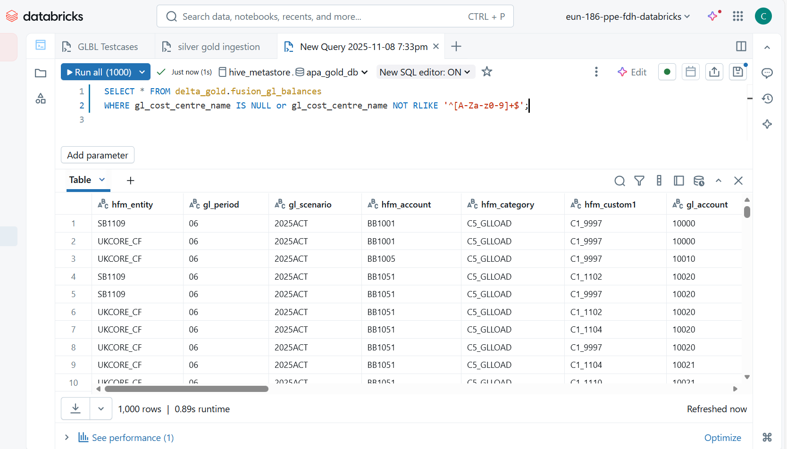

TEST CASE 30 : 30-Verify the column gl_last_extracted is timestamp and not null

QUERY : SELECT * FROM delta_gold.fusion_gl_balances

WHERE gl_last_extracted IS NULL or CAST(gl_last_extracted AS timestamp) IS NULL;

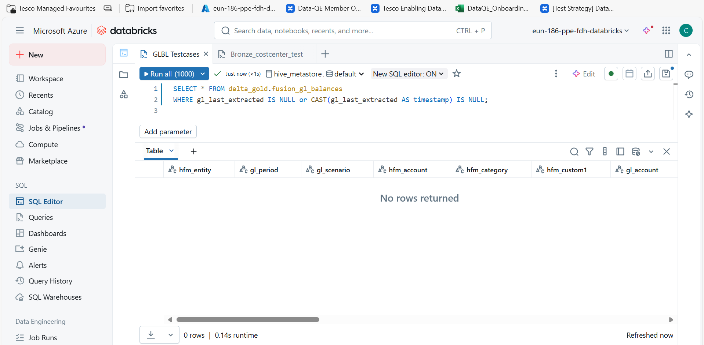

The above query CAST(gl_last_extracted AS timestamp) IS NULL checks if the value cant be converted to a valid timestamp format ( for exa, ‘2024-13-99’ or ‘invalid’). The query returns zero rows, all timestamp values are non null and valid.

TEST CASE 41 : 41-Ensure duplicate records are not loaded into Gold Layer delta_gold.fusion_gl_balances

QUERY : SELECT *, COUNT(*) AS dup_count FROM delta_gold.fusion_gl_balances

GROUP BY hfm_entity, gl_period, gl_scenario, hfm_account, hfm_category, hfm_custom1, gl_account, gl_cost_centre_code, gl_cost_centre_name, gl_ob_debit, gl_ob_credit, gl_movement_debit, gl_movement_credit, gl_periodic_movement, gl_closing_balance, gl_last_extracted, load_date_time, pipeline_run_id, finance_year_period_number, year_period_number

HAVING dup_count > 1

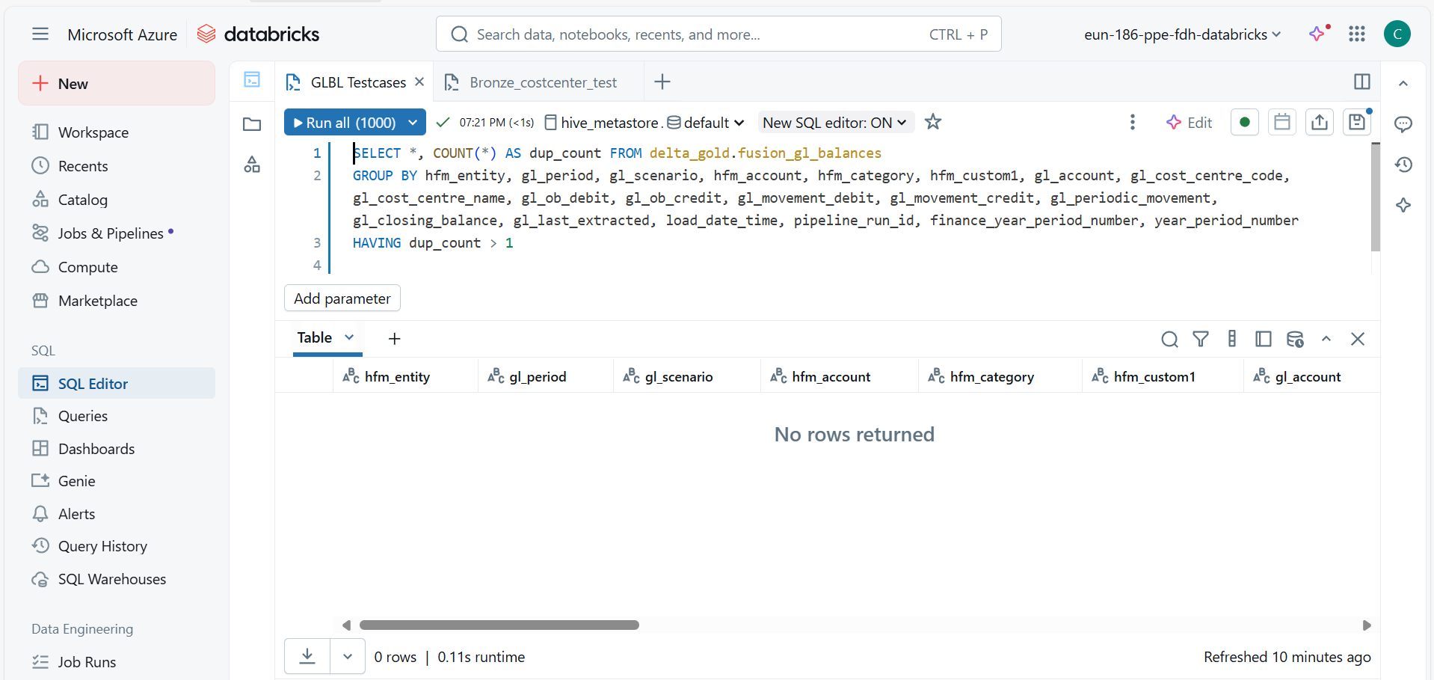

O rows returned, shows that duplicate data was not there.

TEST CASE 2 : 2-Verify on running the job pl_gold_load manually, if the job fails Then data shouldn't move from silver to gold. Email notification should also be triggered for the same.  
  
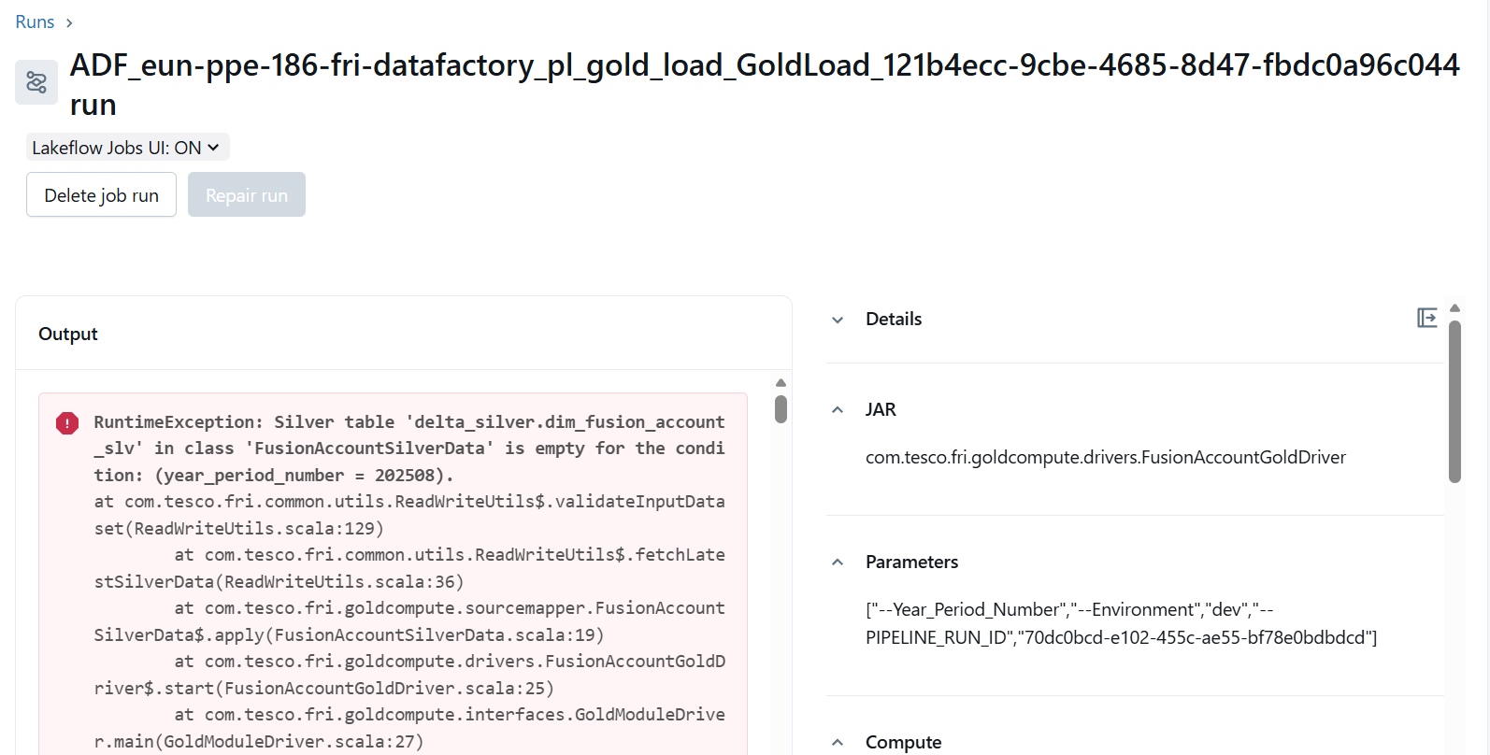

I ran it in dev environment which is pl_gold_load table, but due to lack of data in **delta_silver.dim_fusion_account_slv**  table, it have not ran and it failed. The data doesn’t moved to gold table, checked in ADF Monitor too.

TEST CASE 4 - 4-Verify all the dependency tables/files are available as a prerequisite for loading the table.

Ensure that all required source tables exist, contain data for the specified period, and that the aggregated source data matches the data in the gold table (fusion_gl_balances). This guarantees data integrity before proceeding with the load.

All dependency tables should be accessible:

* dim_fdmee_mapping_slv
* fact_fusion_glbalances_slv
* fact_fdmee_transformed_data
* dim_fusion_account_hierarchy_slv
* dim_fusion_costcentre_slv
* dim_hfm_entity_hierarchy_slv

TARGET TABLE : fusion_gl_balances (gold)

QUERY :

SELECT HFM_ENTITY,

gl_period,

gl_scenario,

hfm_account,

hfm_category,

gl_account,

gl_cost_centre_code,

gl_cost_centre_name,

finance_year_period_number,

ROUND(gl_closing_balance, 2)

FROM (

SELECT a.target_entity AS HFM_ENTITY,

b.period AS gl_period,

b.scenario AS gl_scenario,

a.target_account AS hfm_account,

a.target_ledger AS hfm_category,

a.source_account AS gl_account,

a.source_cost_centre AS gl_cost_centre_code,

e.description AS gl_cost_centre_name,

CONCAT(SUBSTR(b.scenario, 1, 4), b.period) AS finance_year_period_number,

SUM(c.closing_balance) AS gl_closing_balance

FROM delta_silver.dim_fdmee_mapping_slv a

JOIN delta_silver.fact_fusion_glbalances_slv b

ON b.fusion_coa_account = a.source_account

JOIN delta_silver.fact_fdmee_transformed_data c

ON c.fdmee_fusion_string = a.fusion_string

LEFT JOIN delta_silver.dim_fusion_costcentre_slv e

ON a.source_cost_centre = e.fusion_code

WHERE a.year_period_number = 202310

AND b.year_period_number = 202310

AND c.year_period_number = 202310

GROUP BY a.target_entity, b.period, b.scenario,

a.target_account, a.target_ledger,

a.source_account, a.source_cost_centre, e.description

)

MINUS

SELECT hfm_entity,

gl_period,

gl_scenario,

hfm_account,

hfm_category,

gl_account,

gl_cost_centre_code,

gl_cost_centre_name,

finance_year_period_number,

ROUND(gl_closing_balance, 2)

FROM delta_gold.fusion_gl_balances;

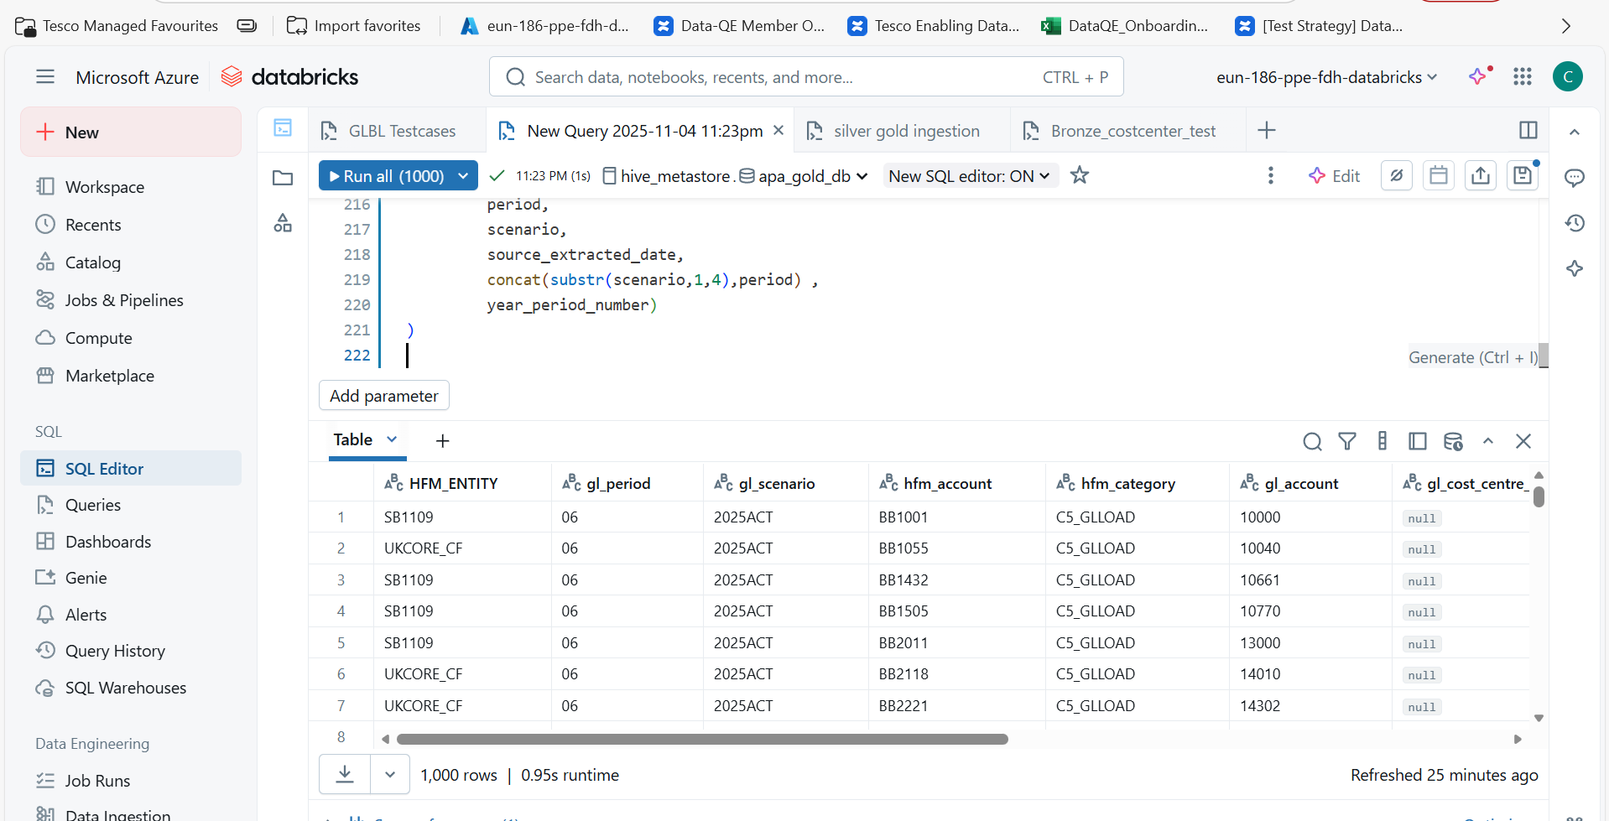

* Result : returned rows that are missing in delta_gold.fusion_gl_balances.

Query Explanation :

* The query compares two datasets to find records that exist in the transformed silver-layer data but not in the gold-layer fusion_gl_balances. This is typically used for reconciliation of GL balances for a specific period.
* It aggregates data from multiple tables in the delta_silver schema. The subquery maps source GL accounts and cost centers to HFM entities and accounts, calculates the closing balance, and prepares key fields like period, scenario, and finance year-period number.
* The subquery joins mapping (dim_fdmee_mapping_slv), GL balances (fact_fusion_glbalances_slv), transformed data (fact_fdmee_transformed_data), and cost center descriptions (dim_fusion_costcentre_slv). It filters for year_period_number = 202310 (October 2023) and groups by entity, account, and cost center.
* The outer query selects the same columns, rounds the closing balance, and uses MINUS to return rows that are missing in delta_gold.fusion_gl_balances.

TEST CASE 6 - 6-Verify the data is loading for all the default columns.

The test case validates that when the pipeline runs successfully and default columns are populated, all default columns contain valid data. The same SQL query is used to check data consistency between the silver-layer transformation and the gold-layer final balances.

Used same query

And I got same output of rows

TEST CASE 7 : 7-Check for primary key column

This table doesn’t have Primary column , so we need to check any duplicates present in table or not .

SQL to detect duplicates:

SELECT hfm_entity,

       gl_period,

       gl_scenario,

       hfm_account,

       hfm_category,

       gl_account,

       gl_cost_centre_code,

       finance_year_period_number,

       year_period_number,

       COUNT(*) AS duplicate_count

FROM delta_gold.fusion_gl_balances

GROUP BY hfm_entity,

         gl_period,

         gl_scenario,

         hfm_account,

         hfm_category,

         gl_account,

         gl_cost_centre_code,

         finance_year_period_number,

         year_period_number

HAVING COUNT(*) > 1;

* GROUP BY on the columns that should uniquely identify a record.
* COUNT(*) > 1 in HAVING finds groups with more than one row means duplicates.

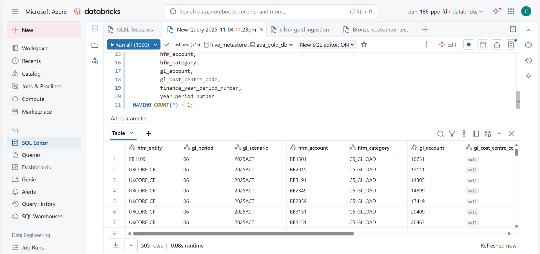

It returned 505 rows, shows duplicates in gold table

TEST CASE 11. 11-Verify the email notification for successful/failure job run.  
  
I ran pl_gold_load, but I didn’t get any email notification  
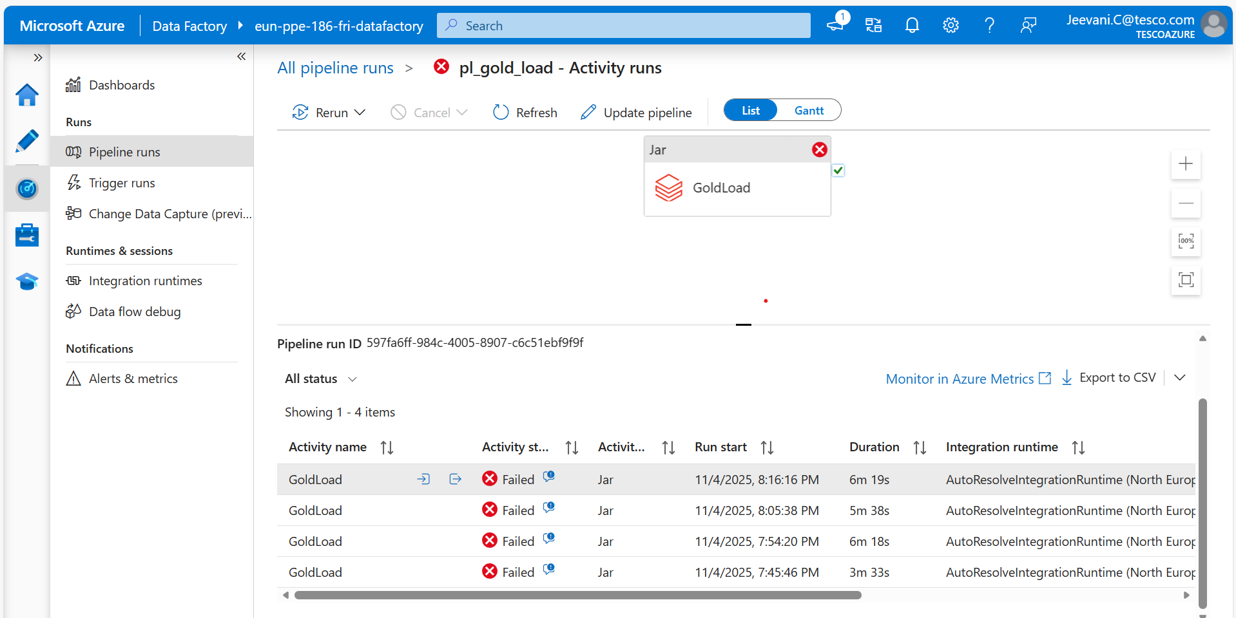

TEST CASE 14 : 14-Verify the column hfm_entity is picked from delta_silver.dim_fdmee_mapping_slv(target_entity) only for 'UKCORE_TOT' entities except 'SB4001','SB4002','SB4003','SB4006' and named as 'UKCORE_CF' except for 'SB1109','SB1151'

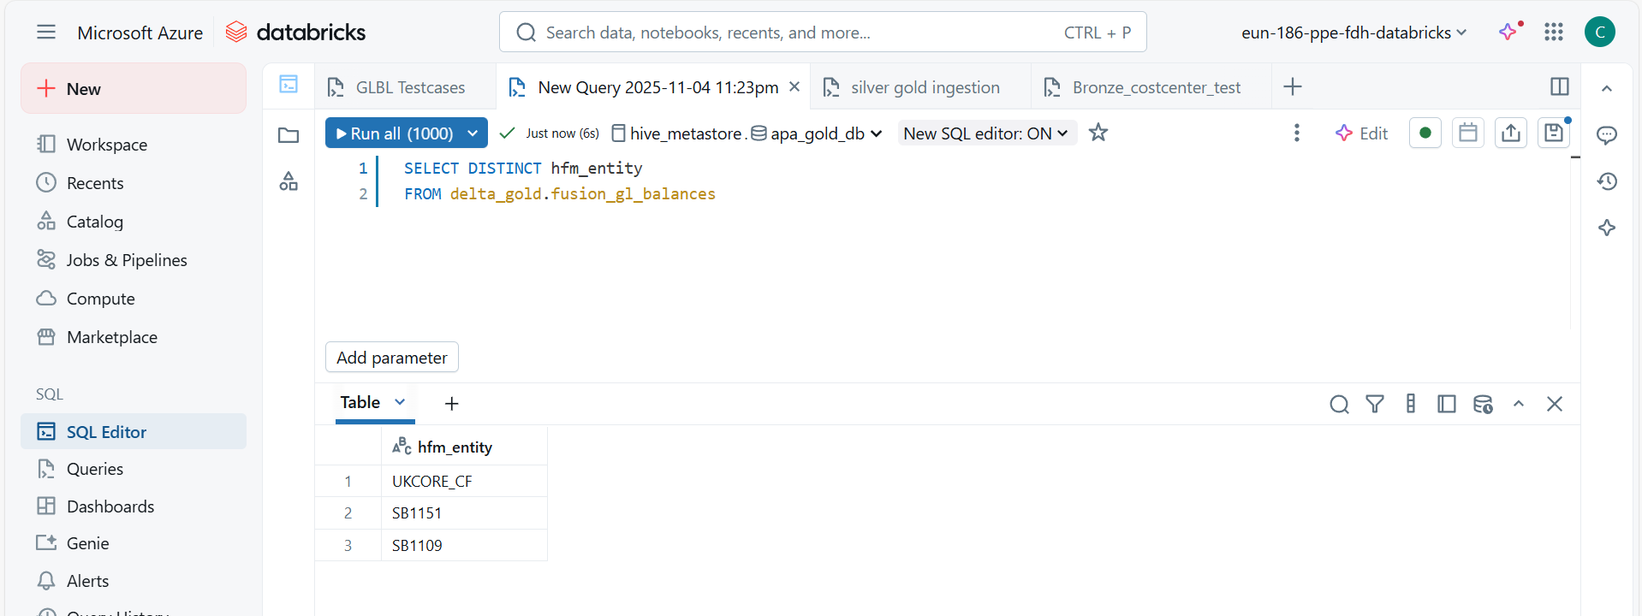

The query shows that data is having unique hfm entities which was shared in same in test case.

TEST CASE 20 : 20-Verify the column hfm_account is mapped from target_account in delta_silver.dim_fdmee_mapping_slv against the source_account

To Verify that hfm_account in delta_gold.fusion_gl_balances is correctly mapped from target_account in delta_silver.dim_fdmee_mapping_slv, based on the corresponding source_account.  
  
Query :

SELECT

    f.year_period_number,

    f.hfm_account,

    m.target_account,

    m.source_account

FROM delta_gold.fusion_gl_balances f

LEFT JOIN delta_silver.dim_fdmee_mapping_slv m

    ON f.hfm_account = m.target_account

WHERE m.target_account IS NULL

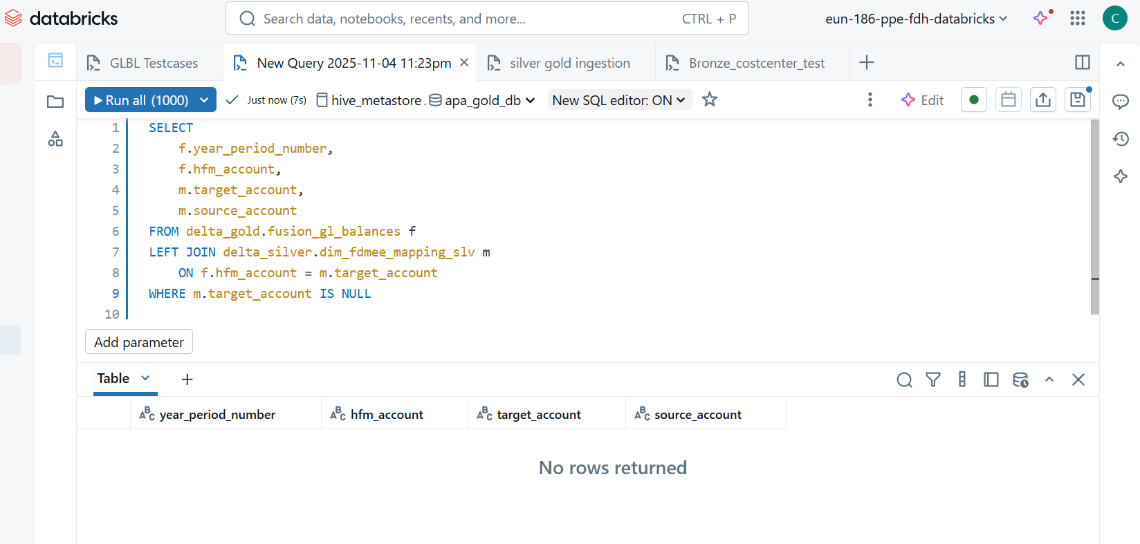

It returned Zero rows, shows mapping are perfect in gold table.

TEST CASE 21 : 21-Verify the column hfm_category is mapped from target_ledger in delta_silver.dim_fdmee_mapping_slv against the source_account

To Verify that hfm_category in delta_gold.fusion_gl_balances is mapped from target_ledger in delta_silver.dim_fdmee_mapping_slv against the corresponding source_account.

Query :

SELECT

    f.year_period_number,

    f.hfm_category,

    m.target_ledger,

    m.source_account

FROM delta_gold.fusion_gl_balances f

LEFT JOIN delta_silver.dim_fdmee_mapping_slv m

    ON f.hfm_category = m.target_ledger

WHERE m.target_ledger IS NULL

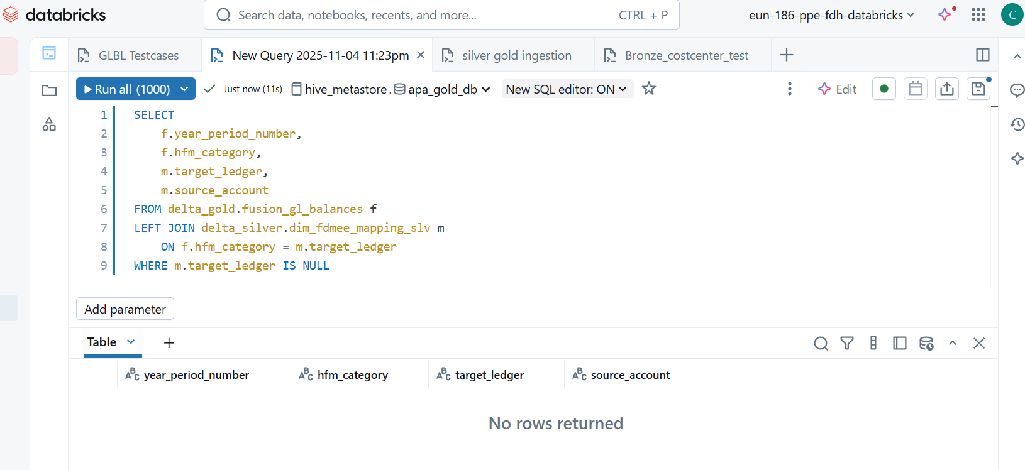

Empty results shows mapping is correct

TEST CASE 23 : 23-Verify the column gl_account is mapped from node in delta_silver.dim_fusion_account_hierarchy only for Balance Sheet and P&L accounts

To Verify that gl_account in delta_gold.fusion_gl_balances is mapped from fusion_code (node) in delta_silver.dim_fusion_account_hierarchy_slv, **only for Balance Sheet and P&L accounts**.

Query :   
  
SELECT

    f.year_period_number,

    f.gl_account,

    h.fusion_code,

    h.account_nature

FROM delta_gold.fusion_gl_balances f

LEFT JOIN delta_silver.dim_fusion_account_hierarchy_slv h

    ON f.gl_account = h.fusion_code

WHERE h.fusion_code IS NULL

   OR (h.account_nature NOT IN ('Balance Sheet', 'P&L'))

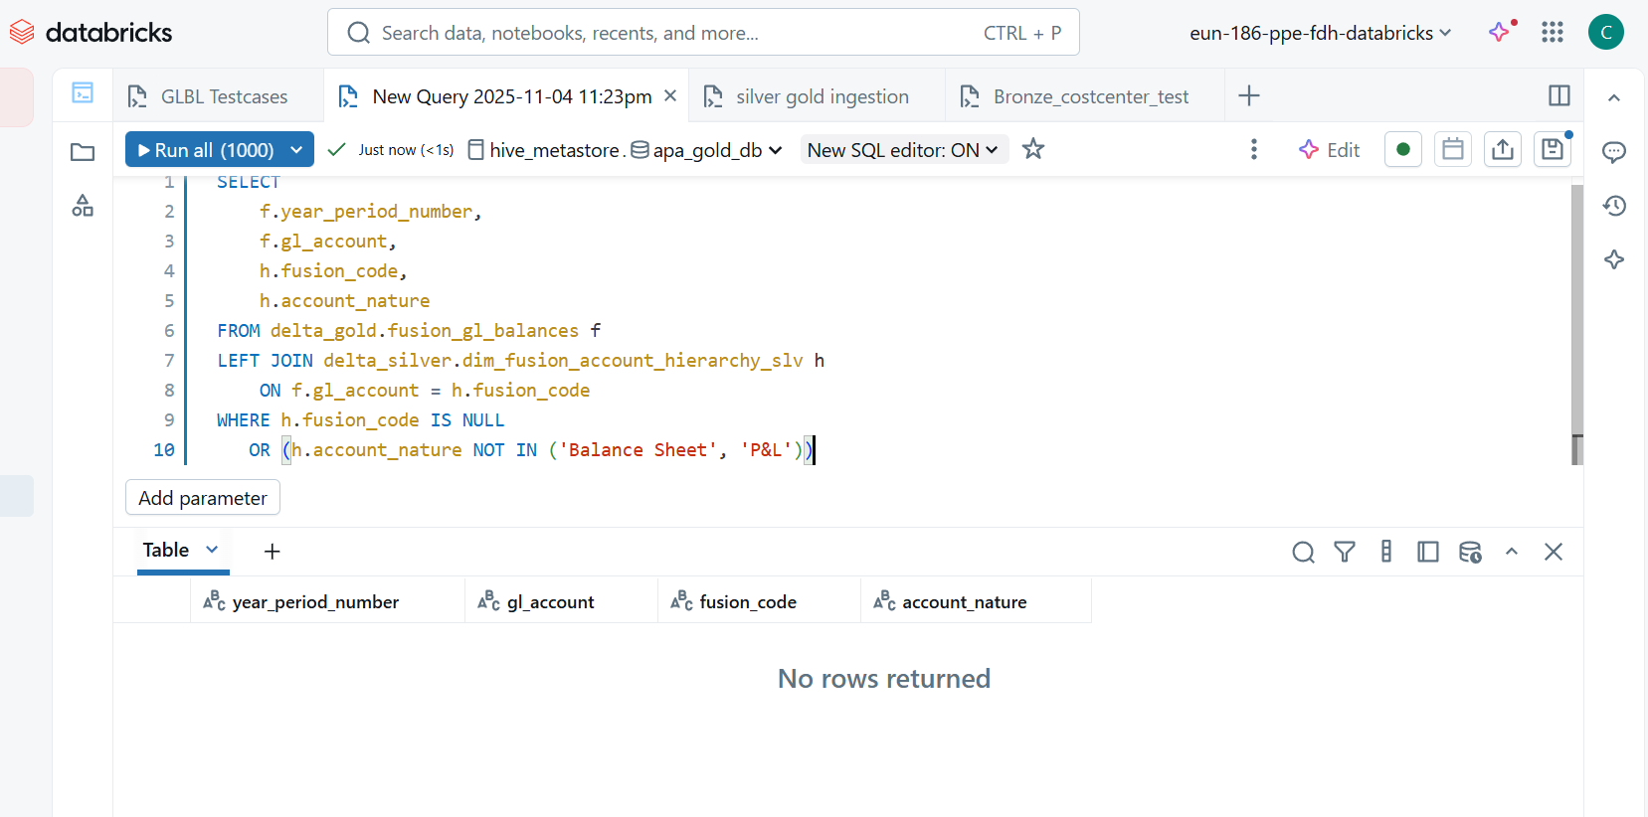

No rows returned shows that mapping is perfect.

TEST CASE 25 : 25-Verify the column gl_cost_centre_code is mapped from source_cost_centre in delta_silver.dim_fdmee_mapping_slv against the source_account, leave blank for Balance Sheet accounts  
To verify gl_cost_centre_code in **delta_gold.fusion_gl_balances** is mapped from source_cost_centre in **delta_silver.dim_fdmee_mapping_slv** against the corresponding source_account.

For **Balance Sheet accounts**, gl_cost_centre_code should be **blank** (NULL or empty).

Query :

SELECT

    f.year_period_number,

    f.gl_account,

    f.gl_cost_centre_code,

    m.source_cost_centre,

    m.source_account,

    m.target_ledger AS hfm_category

FROM delta_gold.fusion_gl_balances f

LEFT JOIN delta_silver.dim_fdmee_mapping_slv m

    ON f.hfm_account = m.target_account

WHERE ((m.target_ledger = 'P&L' AND f.gl_cost_centre_code <> m.source_cost_centre)

        OR

        (m.target_ledger = 'Balance Sheet' AND (f.gl_cost_centre_code IS NOT NULL AND f.gl_cost_centre_code <> '')))

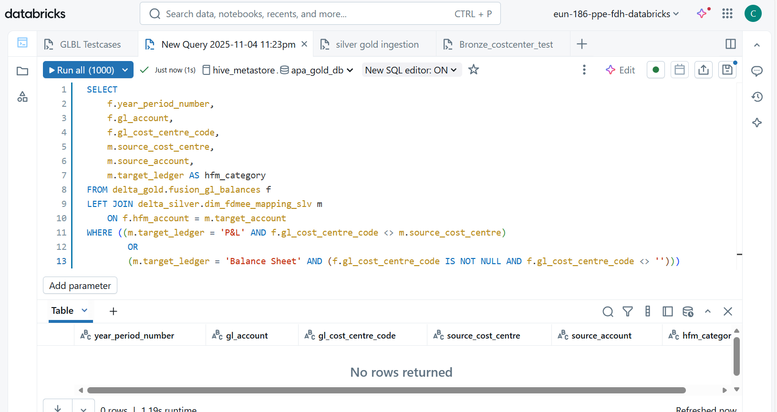

No rows returned shows that mapping is perfect.

Test Case 31 : Verify the columns gl_ob_debit, gl_ob_credit, gl_movement_debit, gl_movement_credit, gl_periodic_movement, gl_closing_balance are mapped from delta_silver.fact_fdmee_transformed_data, summed and aggregated at fusion_account, fusion_cost_centre_code

Descritpion :

This test validates that the columns in the **gold table** delat_gold.fusion_gl_balances (gl_ob_debit, gl_ob_credit, gl_movement_debit, gl_movement_credit, gl_periodic_movement, gl_closing_balance) are correctly mapped and aggregated from the **silver table** delta_silver.fact_fdmee_transformed_data.  
The aggregation should be done by summing the respective columns in the silver table and grouping by fdmee_fusion_string (mapped to gl_account) and source_cost_centre (mapped to gl_cost_centre_code).

Query :

SELECT

    g.gl_account AS fusion_account,

    g.gl_cost_centre_code AS fusion_cost_centre_code,

    g.gl_ob_debit,

    s.silver_ob_debit,

    ABS(g.gl_ob_debit - s.silver_ob_debit) AS diff_ob_debit,

    g.gl_ob_credit,

    s.silver_ob_credit,

    ABS(g.gl_ob_credit - s.silver_ob_credit) AS diff_ob_credit,

    g.gl_movement_debit,

    s.silver_movement_debit,

    ABS(g.gl_movement_debit - s.silver_movement_debit) AS diff_movement_debit,

    g.gl_movement_credit,

    s.silver_movement_credit,

    ABS(g.gl_movement_credit - s.silver_movement_credit) AS diff_movement_credit,

    g.gl_periodic_movement,

    s.silver_periodic_movement,

    ABS(g.gl_periodic_movement - s.silver_periodic_movement) AS diff_periodic_movement,

    g.gl_closing_balance,

    s.silver_closing_balance,

    ABS(g.gl_closing_balance - s.silver_closing_balance) AS diff_closing_balance

FROM delta_gold.fusion_gl_balances g

LEFT JOIN (

    SELECT

        fdmee_fusion_string AS fusion_account,

        source_cost_centre AS fusion_cost_centre_code,

        SUM(ob_debit) AS silver_ob_debit,

        SUM(ob_credit) AS silver_ob_credit,

        SUM(movement_debit) AS silver_movement_debit,

        SUM(movement_credit) AS silver_movement_credit,

        SUM(periodic_movement) AS silver_periodic_movement,

        SUM(closing_balance) AS silver_closing_balance

    FROM delta_silver.fact_fdmee_transformed_data

    GROUP BY fdmee_fusion_string, source_cost_centre

) s

ON g.gl_account = s.fusion_account

AND g.gl_cost_centre_code = s.fusion_cost_centre_code

WHERE

    ABS(g.gl_ob_debit - s.silver_ob_debit) > 0.01 OR

    ABS(g.gl_ob_credit - s.silver_ob_credit) > 0.01 OR

    ABS(g.gl_movement_debit - s.silver_movement_debit) > 0.01 OR

    ABS(g.gl_movement_credit - s.silver_movement_credit) > 0.01 OR

    ABS(g.gl_periodic_movement - s.silver_periodic_movement) > 0.01 OR

    ABS(g.gl_closing_balance - s.silver_closing_balance) > 0.01;

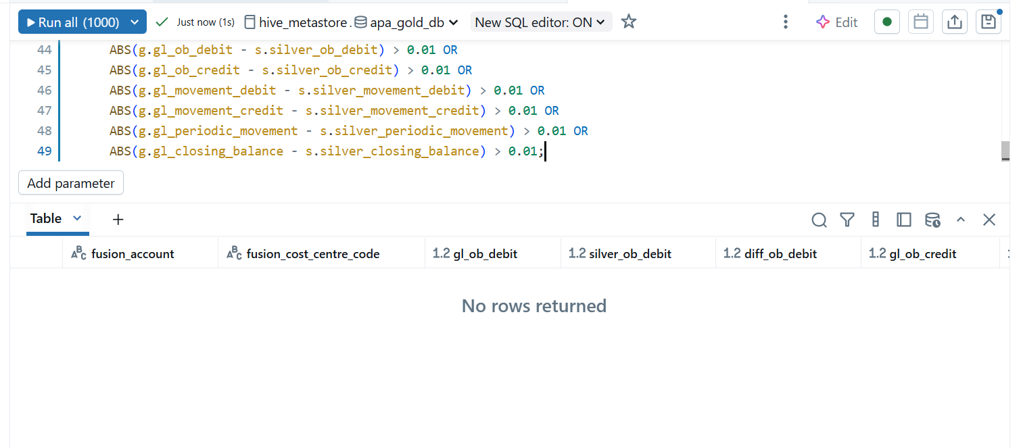

The query was designed to return rows **only when there are mismatches** between the gold table values and the aggregated silver table values.

Since **zero rows were returned**, it means:

* All numeric columns (gl_ob_debit, gl_ob_credit, gl_movement_debit, gl_movement_credit, gl_periodic_movement, gl_closing_balance) in delta_gold.fusion_gl_balances **match perfectly** with the aggregated values from delta_silver.fact_fdmee_transformed_data for the corresponding gl_account and gl_cost_centre_code.

TEST CASE 32 : 32-Verify the columns gl_ob_debit, gl_ob_credit, gl_movement_debit, gl_movement_credit, gl_periodic_movement, gl_closing_balance are numeric

Ensure that the columns gl_ob_debit, gl_ob_credit, gl_movement_debit, gl_movement_credit, gl_periodic_movement, and gl_closing_balance in delta_gold.fusion_gl_balances are numeric (Double).

Query :

SELECT *

FROM delta_gold.fusion_gl_balances

WHERE

    CAST(gl_ob_debit AS DOUBLE) IS NULL AND gl_ob_debit IS NOT NULL

 OR CAST(gl_ob_credit AS DOUBLE) IS NULL AND gl_ob_credit IS NOT NULL

 OR CAST(gl_movement_debit AS DOUBLE) IS NULL AND gl_movement_debit IS NOT NULL

 OR CAST(gl_movement_credit AS DOUBLE) IS NULL AND gl_movement_credit IS NOT NULL

 OR CAST(gl_periodic_movement AS DOUBLE) IS NULL AND gl_periodic_movement IS NOT NULL

 OR CAST(gl_closing_balance AS DOUBLE) IS NULL AND gl_closing_balance IS NOT NULL;

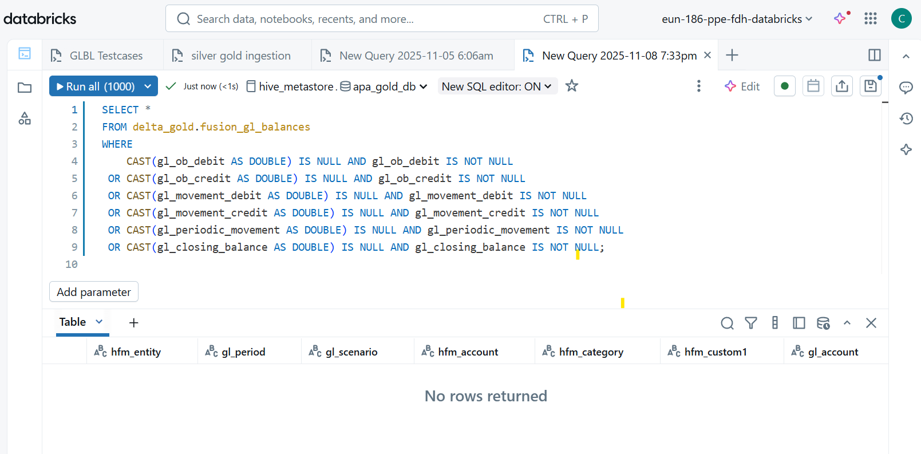

query returns **zero rows**, all values in these columns are numeric (or NULL).

TEST CASE 27 : Ensure that gl_cost_centre_name in delta_gold.fusion_gl_balances is mapped from description in delta_silver.dim_fusion_costcentre_slv based on gl_cost_centre_code = fusion_code. For Balance Sheet accounts (identified by account_type = 'Balance Sheet' in the silver table), gl_cost_centre_name should be blank.

Ensure that gl_cost_centre_name in delta_gold.fusion_gl_balances is mapped from description in delta_silver.dim_fusion_costcentre_slv based on gl_cost_centre_code = fusion_code. For Balance Sheet accounts (identified by account_type = 'Balance Sheet' in the silver table), gl_cost_centre_name should be blank.

Query :

SELECT

    g.gl_account,

    g.gl_cost_centre_code,

    g.gl_cost_centre_name,

    d.description AS expected_description,

    d.account_type

FROM delta_gold.fusion_gl_balances g

LEFT JOIN delta_silver.dim_fusion_costcentre_slv d

    ON g.gl_cost_centre_code = d.fusion_code

WHERE

    (d.account_type <> 'Balance Sheet' AND g.gl_cost_centre_name <> d.description)

    OR (d.account_type = 'Balance Sheet' AND g.gl_cost_centre_name IS NOT NULL AND g.gl_cost_centre_name <> '');

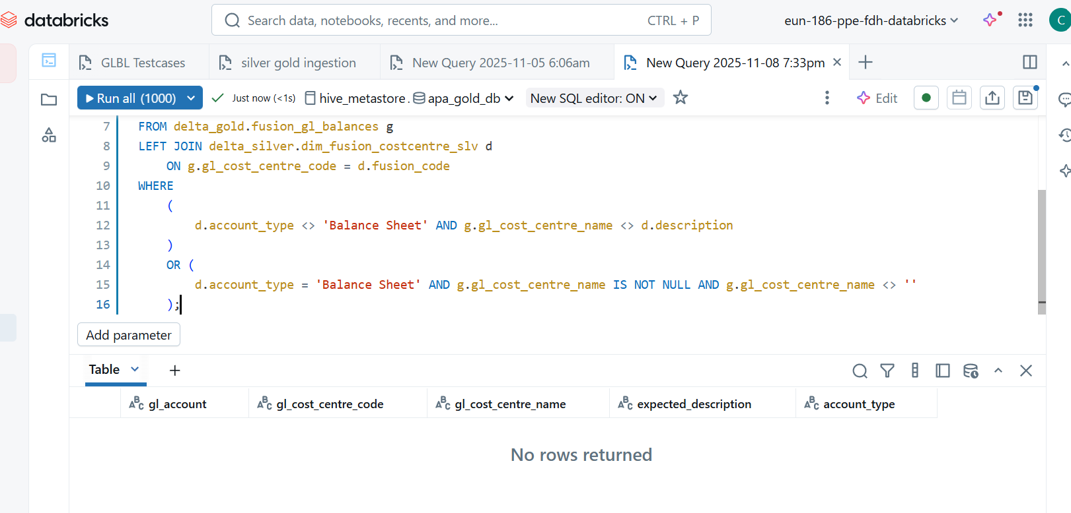

TEST CASE 29 : 29-Verify the column gl_last_extracted is mapped from source_extracted_date in delta_silver.fact_fusion_glbalances_slv only for Tesco GB Primary ledger

Validate that gl_last_extracted in delta_gold.fusion_gl_balances is mapped from source_extracted_date in delta_silver.fact_fusion_glbalances_slv for records where the ledger corresponds to **Tesco GB Primary** (identified via source_ledger in dim_fdmee_mapping_slv).

Query :

SELECT

    g.gl_account,

    g.gl_cost_centre_code,

    g.gl_last_extracted,

    s.source_extracted_date,

    m.source_ledger

FROM delta_gold.fusion_gl_balances g

LEFT JOIN (

    SELECT fusion_coa_account, source_extracted_date, year_period_number

    FROM delta_silver.fact_fusion_glbalances_slv

) s ON g.gl_account = s.fusion_coa_account

LEFT JOIN (

    SELECT source_account, source_ledger, year_period_number

    FROM delta_silver.dim_fdmee_mapping_slv

) m ON s.fusion_coa_account = m.source_account

WHERE m.source_ledger = 'GB TESCO PRIMARY'

AND DATE(g.gl_last_extracted) <> DATE(s.source_extracted_date);

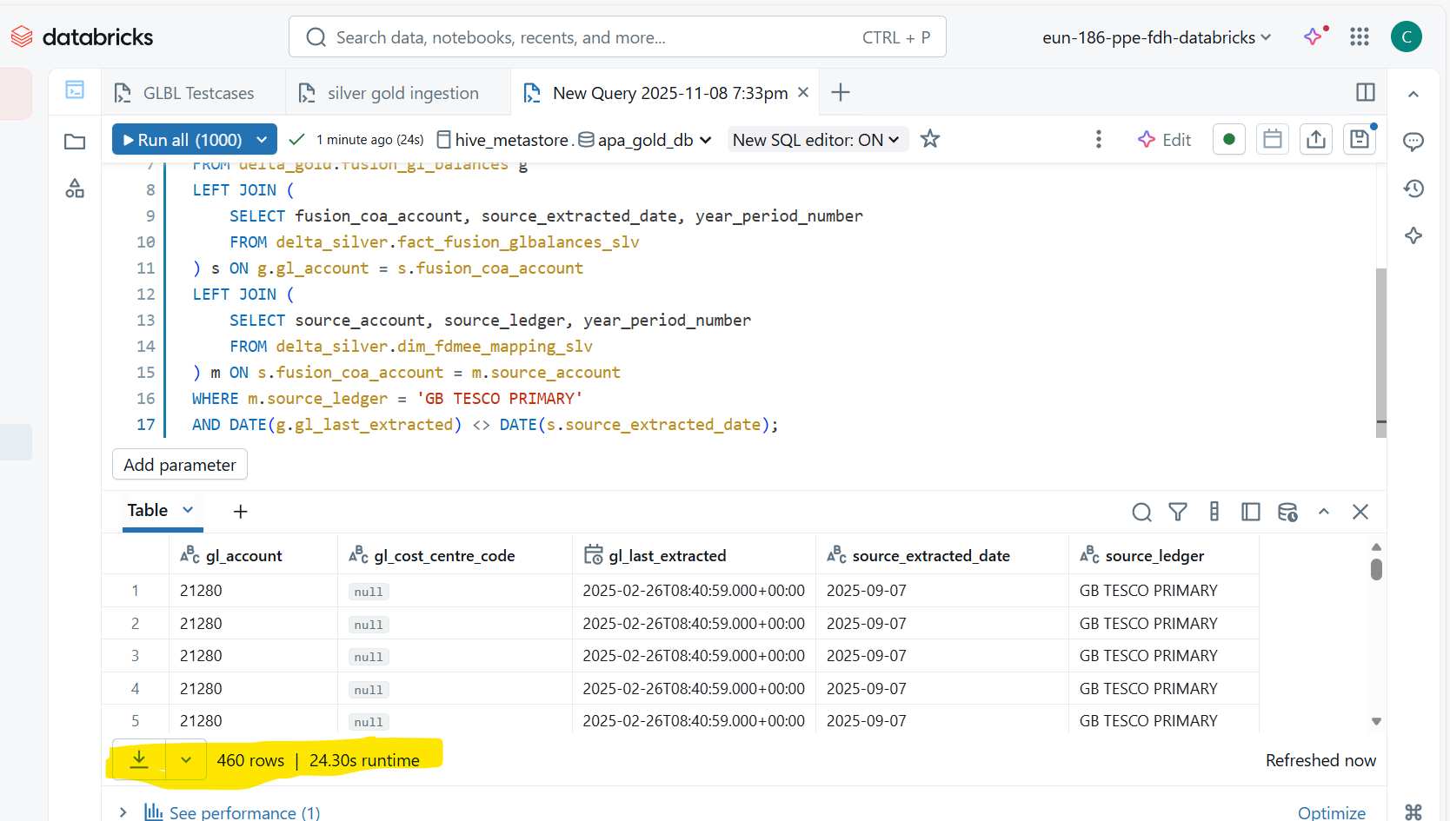

there are **480 mismatches** where gl_last_extracted in the gold table does not match source_extracted_date from the silver table for Tesco GB Primary ledger.

TEST CASE 18 : 18-Verify the column gl_scenario is picked from delta_silver.fact_fusion_glbalances_slv only for Tesco GB Primary ledger and transformed as concat('ACT', balance_period_year)

Ensure that the column gl_scenario in the gold table delta_gold.fusion_gl_balances is derived from the silver table delta_silver.fact_fusion_glbalances_slv for Tesco GB Primary ledger and transformed as concat('ACT', balance_period_year).

Query :

SELECT

g.gl_account,

g.gl_scenario,

CONCAT('ACT', s.balance_period_year) AS expected_gl_scenario,

m.source_ledger

FROM delta_gold.fusion_gl_balances g

LEFT JOIN (

SELECT fusion_coa_account, balance_period_year, year_period_number

FROM delta_silver.fact_fusion_glbalances_slv

) s ON g.gl_account = s.fusion_coa_account

LEFT JOIN (

SELECT source_account, source_ledger, year_period_number

FROM delta_silver.dim_fdmee_mapping_slv

) m ON s.fusion_coa_account = m.source_account

AND g.year_period_number = s.year_period_number

AND g.year_period_number = m.year_period_number

WHERE m.source_ledger = 'GB TESCO PRIMARY'

AND g.gl_scenario <> CONCAT('ACT', s.balance_period_year);

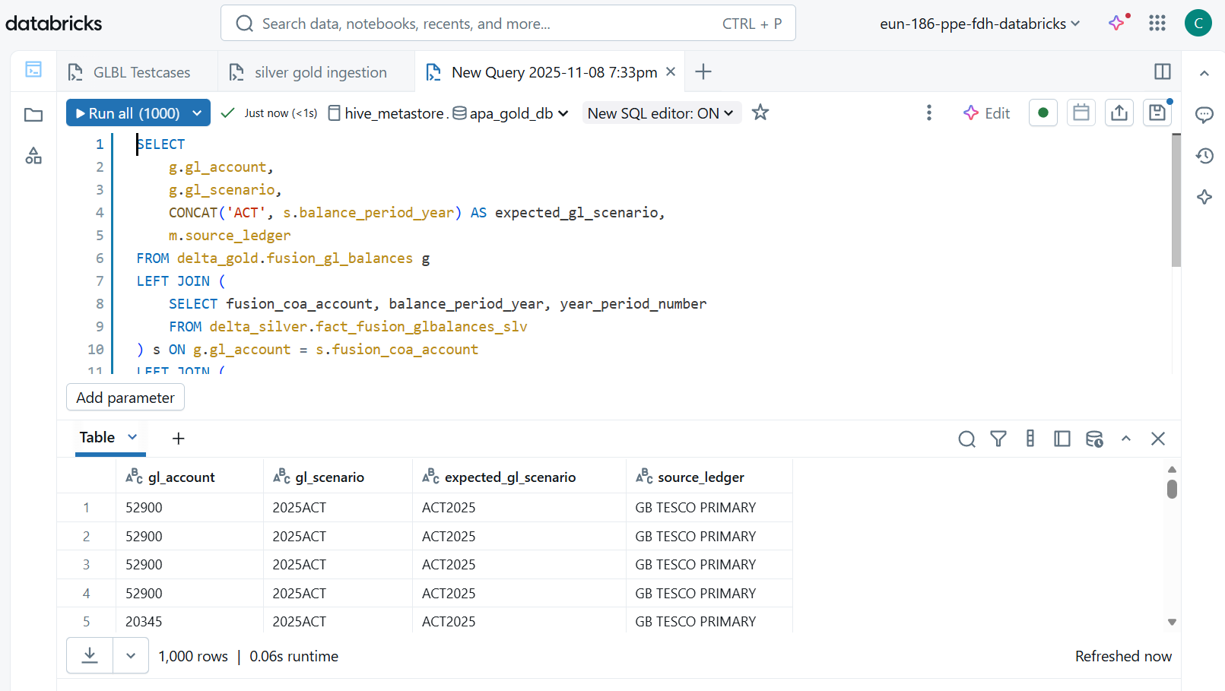

Mismatched

TEST CASE 16 : 16-Verify the column gl_period is picked from delta_silver.fact_fusion_glbalances_slv only for Tesco GB Primary ledger and transformed as concat('0', balance_period_num) if length is 1

Ensure that the column gl_period in the gold table delta_gold.fusion_gl_balances is derived from balance_period_num in the silver table delta_silver.fact_fusion_glbalances_slv for Tesco GB Primary ledger, and transformed as:

If length(balance_period_num) = 1 → concat('0', balance_period_num)

Else → balance_period_num

QUERY :

SELECT

g.gl_account,

g.gl_period,

CASE

WHEN LENGTH(s.balance_period_num) = 1 THEN CONCAT('0', s.balance_period_num)

ELSE s.balance_period_num

END AS expected_gl_period,

m.source_ledger

FROM delta_gold.fusion_gl_balances g

LEFT JOIN (

SELECT fusion_coa_account, balance_period_num, year_period_number

FROM delta_silver.fact_fusion_glbalances_slv

) s ON g.gl_account = s.fusion_coa_account

LEFT JOIN (

SELECT source_account, source_ledger, year_period_number

FROM delta_silver.dim_fdmee_mapping_slv

) m ON s.fusion_coa_account = m.source_account

AND g.year_period_number = s.year_period_number

AND g.year_period_number = m.year_period_number

WHERE m.source_ledger = 'GB TESCO PRIMARY'

AND g.gl_period <> CASE

WHEN LENGTH(s.balance_period_num) = 1 THEN CONCAT('0', s.balance_period_num)

ELSE s.balance_period_num

END;

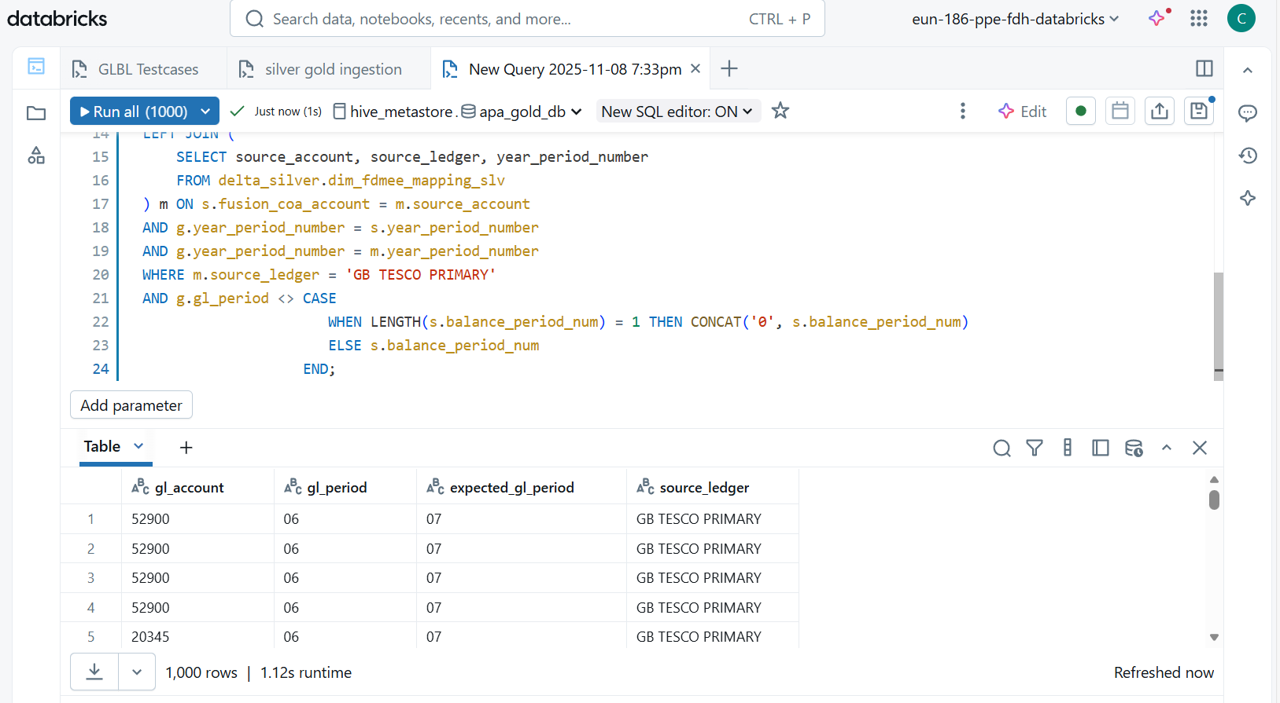

We have rows returned

TEST CASE 48-Verify the HFM code and Fusion Code are not same

QUERY : select distinct hfm_account, gl_account from delta_gold.fusion_gl_balances

where hfm_account =gl_account

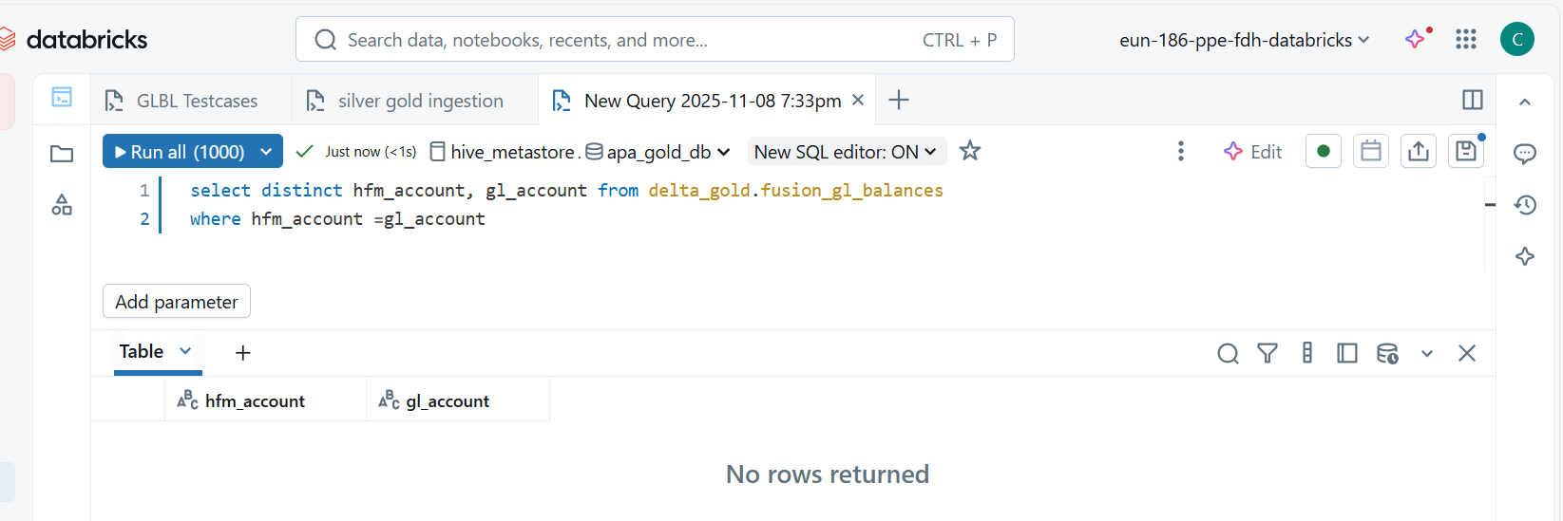

Test case passed.

TEST CASE 42 : 42-Validate any primary key (gl_account, gl_cost_centre_code) duplicate is there in Gold Layer delta_gold.fusion_gl_balances  
  
Ensure that the combination of gl_account and gl_cost_centre_code in delta_gold.fusion_gl_balances is unique (no duplicates).

QUERY :

SELECT

gl_account,

gl_cost_centre_code,

COUNT(*) AS duplicate_count

FROM delta_gold.fusion_gl_balances

GROUP BY gl_account, gl_cost_centre_code

HAVING COUNT(*) > 1;

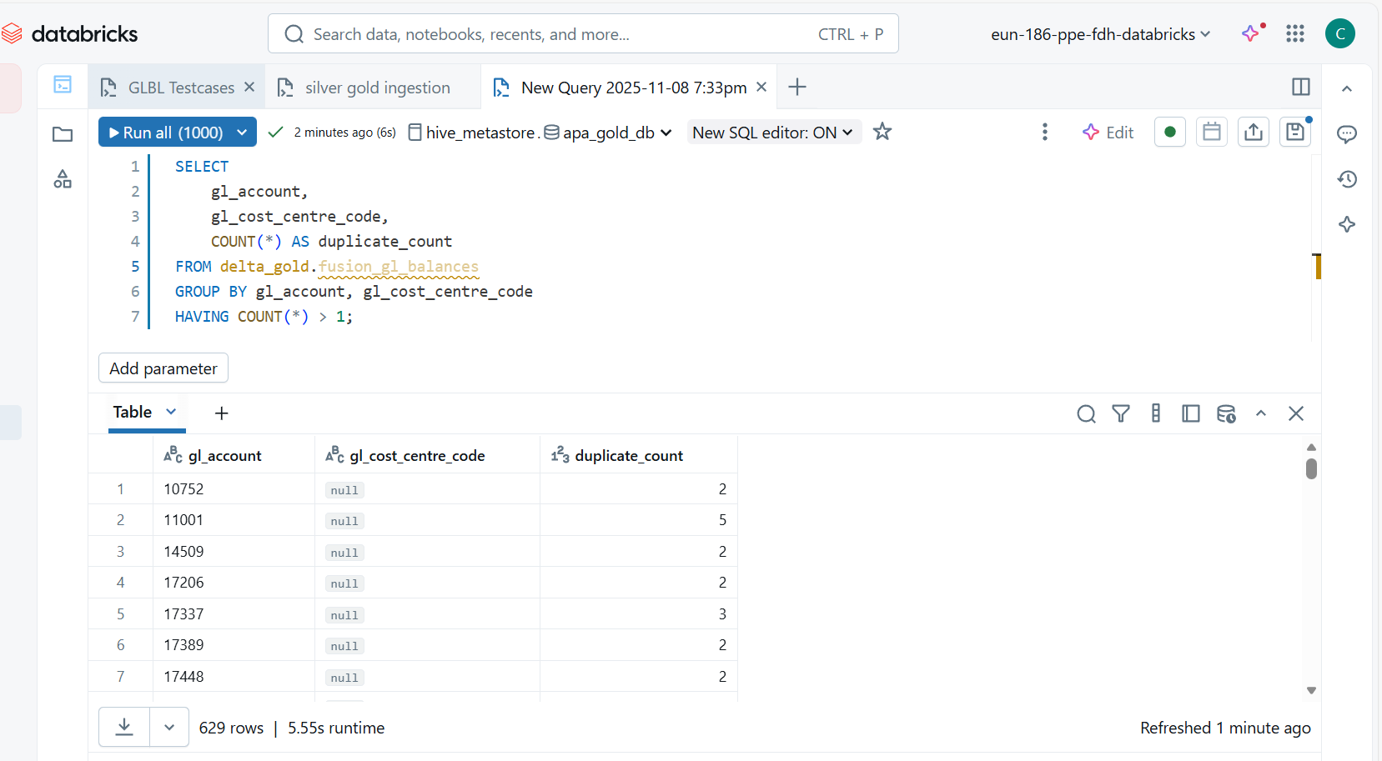

Duplicates are there

TEST CASE 39 : 39-Validate finance_year_period_number is null or defaulted as per logic

Ensure that the column finance_year_period_number in delta_gold.fusion_gl_balances is either:

* **Null** when no valid transformation applies, OR
* **Defaulted correctly** based on the business logic (usually concat(substr(gl_scenario,1,4), gl_period)).

**✅ Business Logic:**

* If gl_scenario and gl_period exist, then:
* finance_year_period_number = concat(substr(gl_scenario,1,4), gl_period)
* Else, it should be **NULL** or a defined default.

QUERY :

SELECT

    gl_account,

    gl_period,

    gl_scenario,

    finance_year_period_number,

    CASE

        WHEN gl_scenario IS NOT NULL AND gl_period IS NOT NULL

        THEN CONCAT(SUBSTR(gl_scenario,1,4), gl_period)

        ELSE NULL

    END AS expected_finance_year_period_number

FROM delta_gold.fusion_gl_balances

WHERE finance_year_period_number <> CASE

                                        WHEN gl_scenario IS NOT NULL AND gl_period IS NOT NULL

                                        THEN CONCAT(SUBSTR(gl_scenario,1,4), gl_period)

                                        ELSE NULL

                                    END;

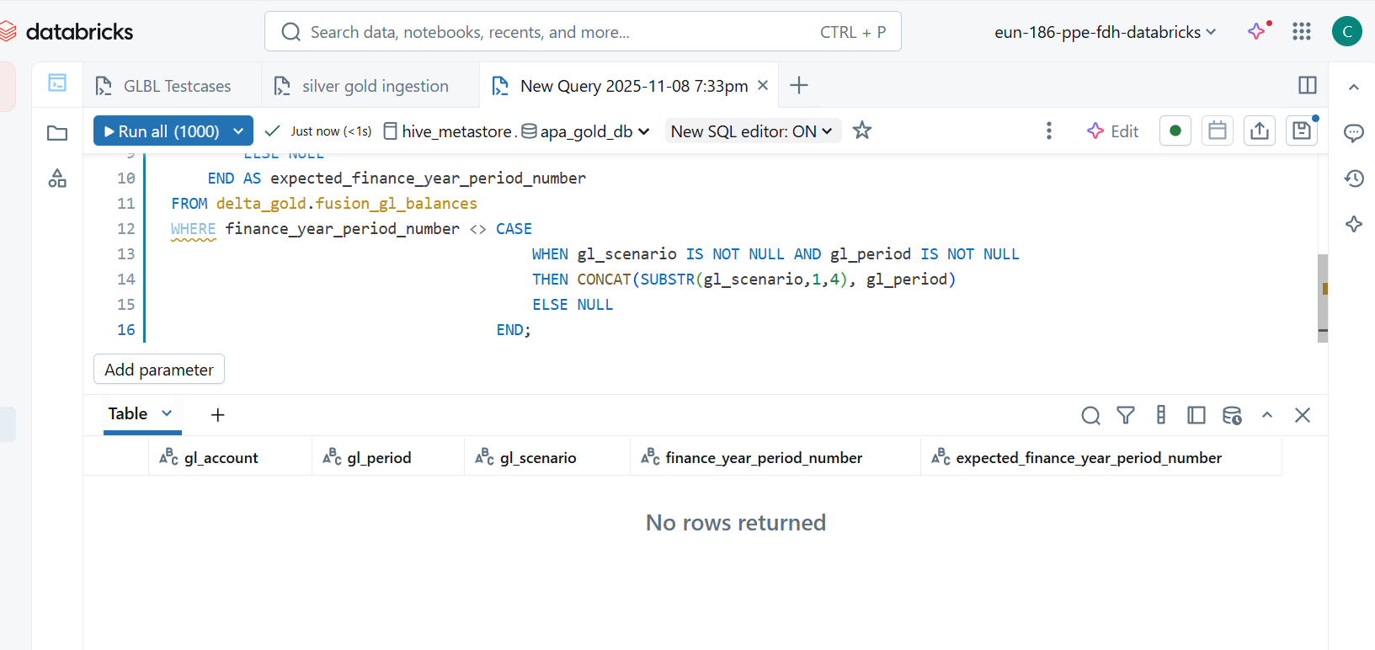

TEST CASE 38-Validate pipeline_run_id is correctly generated and unique per run

Ensure that the column pipeline_run_id in delta_gold.fusion_gl_balances:

* Is **not null**.
* Is correctly generated (matches expected format or pattern).
* Is **unique for each pipeline run**.

QUERY :

SELECT COUNT(*) AS null_or_empty_count

FROM delta_gold.fusion_gl_balances

WHERE pipeline_run_id IS NULL OR TRIM(pipeline_run_id) = '';

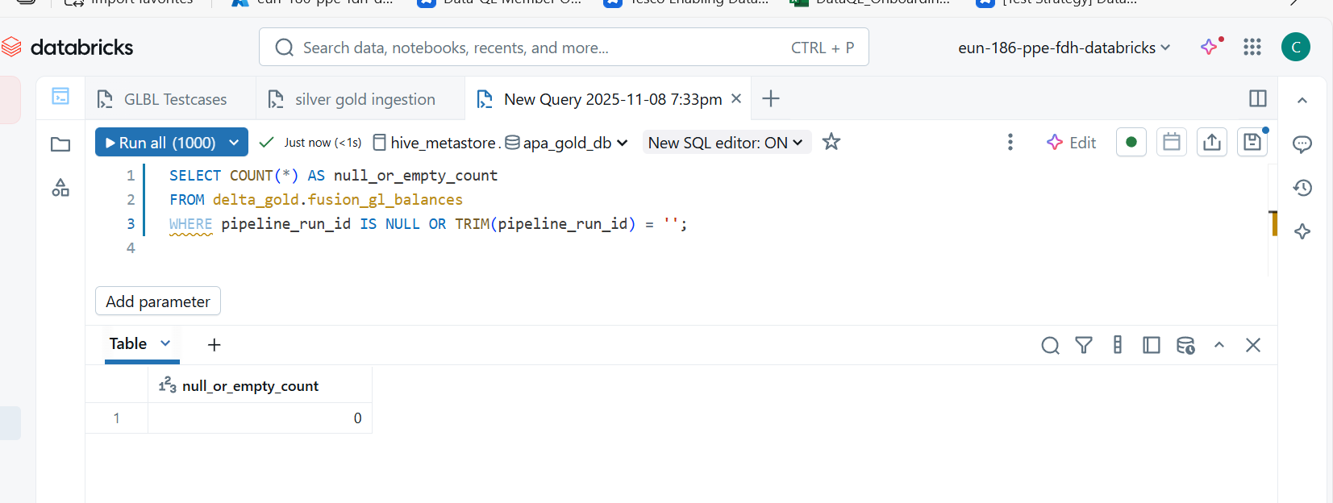

QUERY :

SELECT DISTINCT pipeline_run_id

FROM delta_gold.fusion_gl_balances

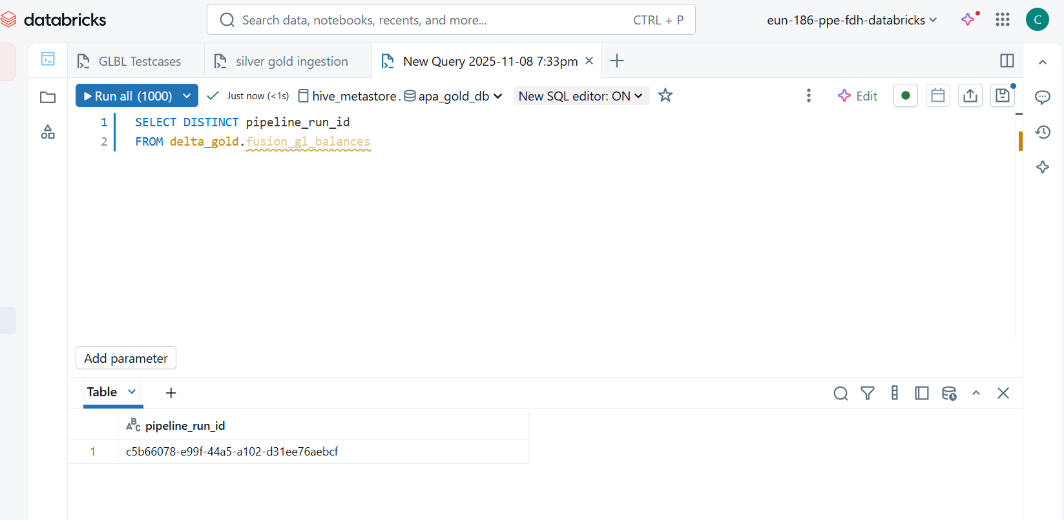

TEST CASE 49 : 49-Verify passing invalid YEAR_PERIOD_NUMBER in pipeline parameter and see how it

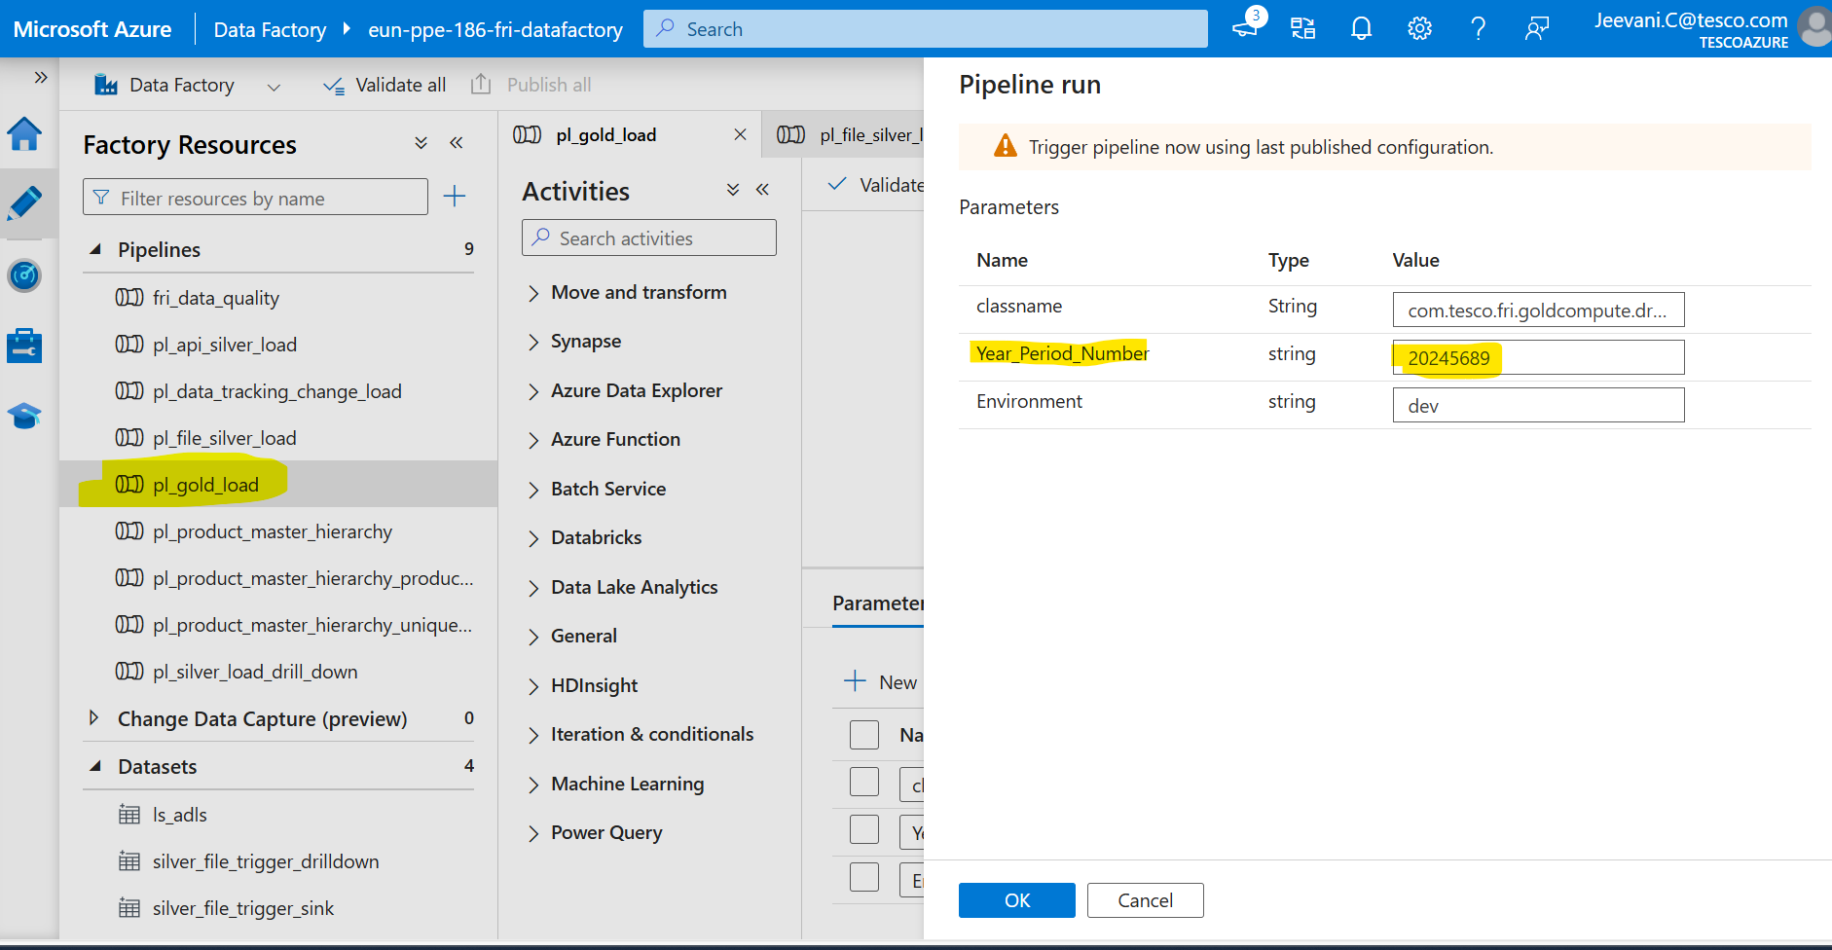

Output :

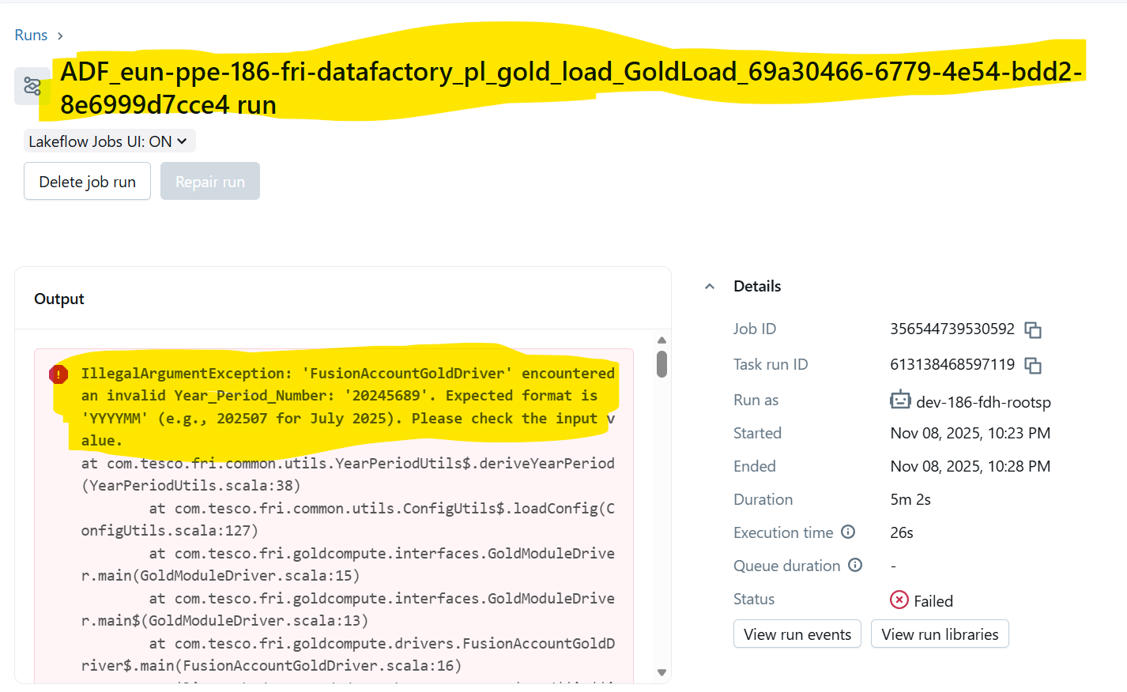

TEST CASE 53 : 53-Ensure all the tables are joined based on same year_period_number

Validate that all tables in the gold layer ETL process are joined using the same year_period_number to maintain period consistency.

QUERY :

SELECT g.year_period_number AS gold_period,

s.year_period_number AS silver_glbalances_period,

m.year_period_number AS mapping_period

FROM delta_gold.fusion_gl_balances g

LEFT JOIN delta_silver.fact_fusion_glbalances_slv s

ON g.gl_account = s.fusion_coa_account

LEFT JOIN delta_silver.dim_fdmee_mapping_slv m

ON g.gl_account = m.source_account

WHERE (s.year_period_number IS NOT NULL AND s.year_period_number <> g.year_period_number)

OR (m.year_period_number IS NOT NULL AND m.year_period_number <> g.year_period_number);

Output :

